Mr Toomey
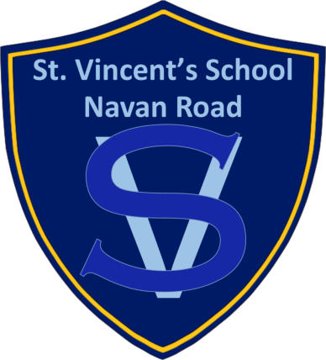
St. Vincent’s Special School
Saint Vincent’s Centre,
Navan Road,
Dublin 7
(Near Phoenix Park)

Eircode: D07N229
Principal's name: Cathy Cawley
Phone number: 01 8245491
Email address: principalstvincents@eircom.net
Website address: www.stvincentsspecialschool.ie

School for:
Moderate, severe and profound general learning disability
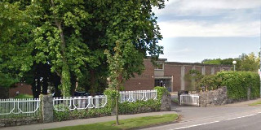
(GLD), and autistic spectrum disorder (ASD).

Mr Toomey
General Information:
- It is a school for students of primary and post-primary age with special educational needs (SEN) arising from moderate, severe and
profound general learning disability (GLD), and autistic spectrum disorder (ASD).
- 67 students
- Co-educational school
- Last whole school inspection was in 2017
- The school has 14 classroom teachers, 27 special-needs assistants (SNAs), a part-time Physical Education teacher funded by the Department of Education and Skills, and a part-time Home Economics teacher.
- The multi-disciplinary services to the school provided by the Daughters of Charity Services, include
- a clinical nurse specialist
- occupational therapist
- psychologist
- speech and language therapist.
- Social Worker
- Physiotherapy
- Behaviour Specialist Support
- Psychiatry Services
- Paediatrician Consultant Service
- Students attend the school from a wide catchment area across north and west Dublin.
- Funded transport for students.
- The school engages with the Junior Certificate Level 2 and the Award Scheme Development and Accreditation Network (ASDAN)
- Aistear is used with junior children
- Augmentative communication approaches, including manual signing for people with disabilities (LÁMH) and the Picture Exchange Communication System (PECS) are used in the school.

Mr Toomey

- Emphasis on Social Personal and Health Education (SPHE) in order to develop personal, social and life-skills.
- Gardening, swimming, choir, Home Economics and Art are additional areas taught.
- Access to the July Provision Scheme.
- Social outings including trips to the cinema, bowling, out for lunch and shopping trips. While on these outings we work on developing many different skills including money skills, independent living skills and road safety skills.
- Older students enjoy daily socialisation training, swimming, PE, Home Economics and a weekly woodwork class at Castleknock CC.
- The school has a canteen.
- Equine therapy (6 week course) for senior classes.

- Subjects taught: Communication and Language, Drama, Mathematics, Music, Physical Education, SESE: History, SESE: Geography, SESE: Science Social, Personal and Health Education, Visual Arts.
- Pupils of post primary age are engaging with the recently developed Junior Certificate Level 2 Learning Programmes (L2LPs) designed for students who have general learning disabilities in the higher functioning moderate category. This is year one of implementing this syllabus in the school.​ Senior pupils are working towards certification in ASDAN.

Mr Toomey
NCCA CURRICULUM LINK
In addition to the NCCA Guidelines Our whole school planning includes the following programmes that are a learning requirement for our pupils and are carried out on a daily basis:
- An Oral motor Skills programme
- Monthly themes for Core vocabulary
- Can Do Reading Programme
- Conversation Cards on topics – Food, Drinks Treats Animals, Places Sports, TV
- Conversation Development Questions – personal/ family/school / activities/ time
- The SESE Functional Language & Communication
- SESE- Social Skills/ Orientation Programme of St Vincent's School allows the pupils to explore the local environment moving from the immediate class to school environment.
The next stage is the grounds and campus of St Vincent's Centre, moving on to the local shops, and local shopping Centre areas
Pupils and staff use a range of augmentative and alternative communication strategies, including objects-of-reference (OoR), photographs, pictures, object schedules, visual schedules, PECS (Picture Exchange Communication System), Lámh.
Junior Cycle Level 1& 2 Learning Programmes
At Senior Level the Curricular Emphasis is on Learning for Life This functional curriculum is comprised of four domains:
- Career Development
- Personal Development/interpersonal skills,
- Independent Living
- Functional Academics.
Certification will be provided through the ASDAN Award Scheme Development and Accreditation Network) Towards Independence Programme.
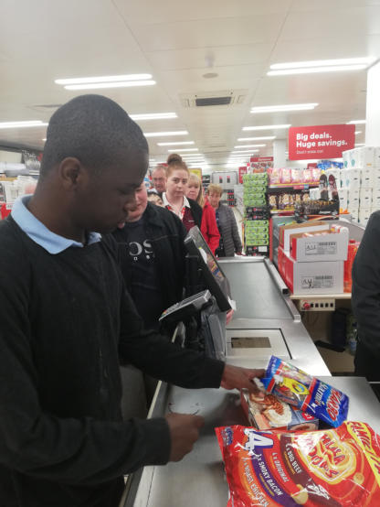
- Using Leisure Time
- Using ICT
- Meal Preparation & Cooking
- Independent Living

