Mr Toomey
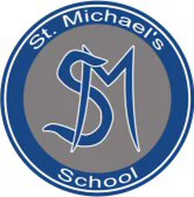
St. Michael’s Special School
Holy Angels,
Glenmaroon,
Chapelizod,
Dublin 20
Principal: SHARON GOREVAN
Phone number: 01 8201859
Eircode: D20A072
Email address: principalgorevan@gmail.com
Website address: www.stmichaelsholyangels.com
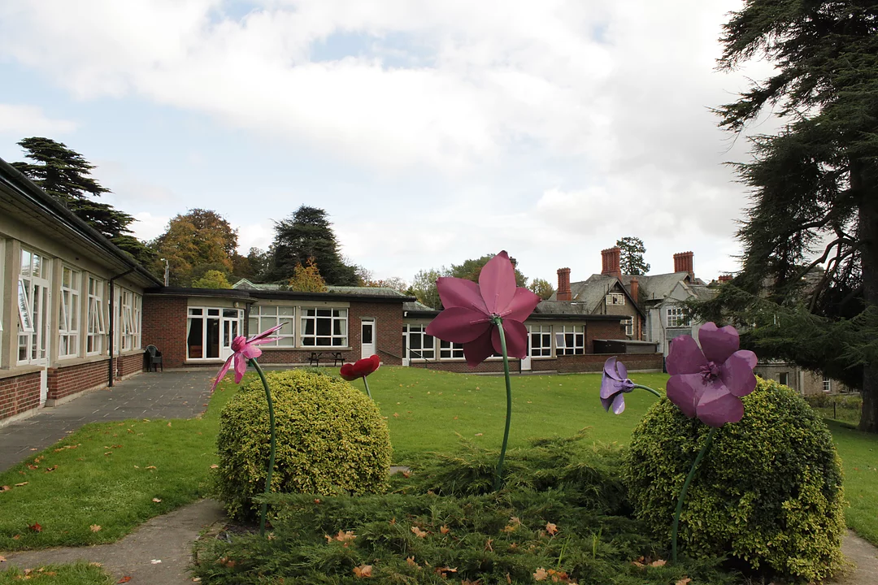

School for: Mild general learning disability & mild general learning disability with an associated difficulty, e.g. Autistic Spectrum Disorder.
May accept pupils who, on psychological testing, are found to be of mild/borderline ability and who, in addition, have other significant needs, e.g. language delay, speech impairment.

Mr Toomey
General information:
- St. Michael's School caters for pupils with a Mild General Learning Disability.
- The school currently has an enrolment of approximately 166 pupils ranging in age from 5-18 years.
- St. Michael’s School is under the trusteeship of the Daughters of Charity.
- St. Michael’s School is a co-educational school
- It caters for pupils on psychological testing, are found to be functioning within the level of mild general learning disability (i.e. full-scale I.Q. between 50 to 69).
- We also cater for pupils with a Borderline Mild General Learning Disability (full I.Q. scale between 70 to 79) who in addition have other significant need e.g. severe language impairment.
- The pupil/ teacher ratio for such pupils is 11 to 1.
- It is not a school that caters for pupils with emotional and behavioural difficulties.
- Referrals are considered on an individual basis giving due regard to both the characteristic designation of the school and the provision of adequate resources by the Department of Education & Skills (DES) and the National Council for Special Education (NCSE).
- Applications for enrolment should be directed to the School Principal, acting on behalf of the Board of Management.
- Pupils must be aged 5 years of age on or before 1st January of the year in which they are applying.
- At present, the staff comprises 1 Principal, 21 Teachers, 1 Home Economics Teacher, 1 Woodwork Teacher, 1 part time P.E. teacher, 22 Special Needs Assistants (SNAs), 5 ancillary staff and 19 bus escorts.
- Bus service to and from the school is provided
- All pupils attend school from 9.20 a.m. to 3.00 pm to facilitates transport to and from school. In the interests of some pupils it may be necessary to shorten the day further if parents or school staff feel that the pupil would benefit from a shorter school day.

Mr Toomey
Curriculum
- All pupils have access to a broad, balanced, relevant, differentiated Curriculum which enables them to develop intellectually, spiritually, morally, emotionally and physically.
- St. Michael's School is keen to develop personal and social skills alongside academic achievement.
- In conjunction with the 'Primary School Curriculum' (1999) and the National Council for Curriculum and Assessment, 'Guidelines for Teachers of Students with Mild General Learning Disabilities', the following subjects are taught:
- English
- Mathematics
- History
- Geography
- Science
- Visual Studies
- Music
- Drama
- Physical Education
- Social, Personal and Health Education
- Religion
- Pupils are prepared for the Sacraments of Penance/Reconciliation, Eucharist and Confirmation.
- The school also provides recognised post-primary programmes including the Junior Cycle programmes, level 2, level 3 subjects (Art, Craft and Design and Home Economics), as well as modules from Quality and Qualifications Ireland (QQI) level 3 (Woodwork, Food and Nutrition, Ceramics, Music Appreciation, Application of Number, Computers, Horticulture/Container Gardening, Health & Fitness, Art Appreciation and Communications).
- As the pupil’s progress towards the Senior School, the following subjects are available: Computer Studies, Home Economics and Woodwork.
- Opportunities to progress to certification level exist in the areas of Junior Certificate (Level 2 & 3), QQI (Level 3). Pupils will be appropriately placed depending upon age and ability.

Mr Toomey
Facilities:
In the main building there are 12 classrooms,
- a Computer Room,
- Assembly Hall,
- Home Economics Room,
- a large Dinner Room.
- A gym
- A Woodwork Room,
- Craft Room,
- Art room
- An outdoor Football pitch
- A basketball court.
- In 2011 a new building was opened which gave the school an additional 2
classrooms and 3 resource rooms.
- We have a heated indoor Sports Hall that is used for gymnastics, basketball, indoor soccer, volleyball, dance and hockey.
- Our school is a member of the Irish Special Schools Sports Council and our pupils participate in national soccer, basketball, athletics and cross country events throughout the year.
- We also use local swimming facilities to provide our pupils with the opportunity to take swimming lessons and we send our swimming team to compete in the annual ISSSC sponsored swimming gala each year.
- The computer room has 8 desktop computers and one printer. Each class has a timetabled lesson. The Junior pupils attend with their own class teacher and Senior school pupils work with a Computers teacher. Pupils also benefit from technology in their class as each room is fitted with an overhead projector and an interactive whiteboard.
- Our Home Economics room is bright and spacious and is equipped with 4 cooking/preparation areas accommodating two pupils at each area.
- In Home Economics class pupils learn about the benefits of a healthy diet and lifestyle and during practical lessons they prepare a range of healthy snacks/meals.
- In Woodwork, pupils will learn fundamental life skills such as planning projects, managing their workspace and organising themselves to complete woodwork projects and a portfolio of work. Pupils will learn these skills in a very hands-on manner within a safe environment. Pupils use hand tools to build their skills for example, chisels, mallets, screwdrivers, tenon saws, planes, try-squares and a ruler/measuring tapes.

Mr Toomey
- We have a library that is stocked with a number of reading schemes for all ages and abilities. We take part in the annual 'World Book Day' holding 'book swaps' and we invite authors and story tellers from Poetry Ireland to come and perform to our pupils.
- St Michael's School has several choirs that offer pupils who enjoy singing a chance to perform at mass, communions, confirmations and other school events.

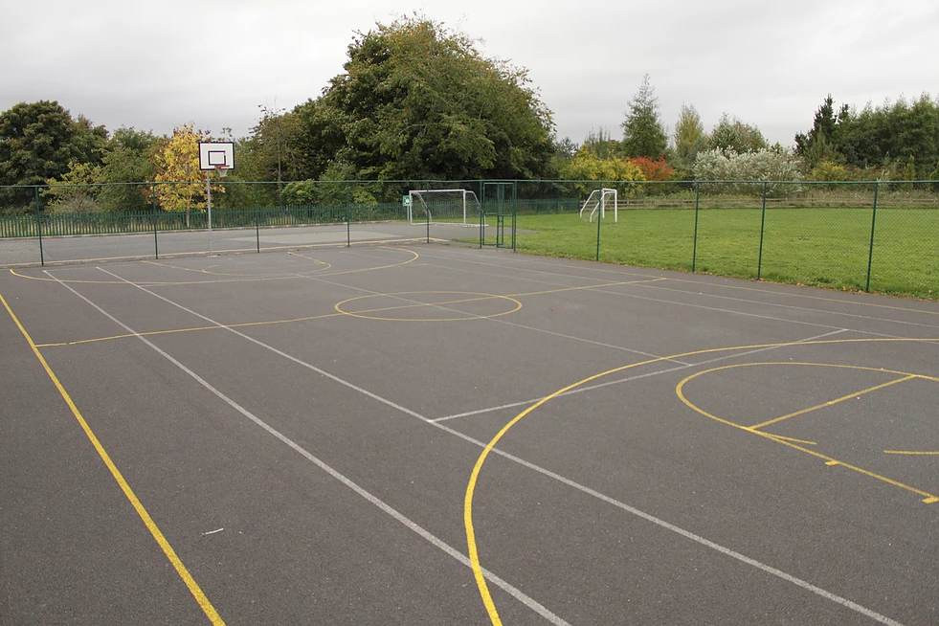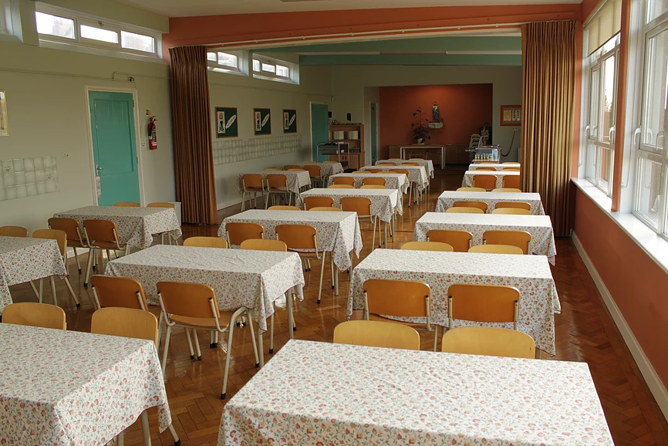
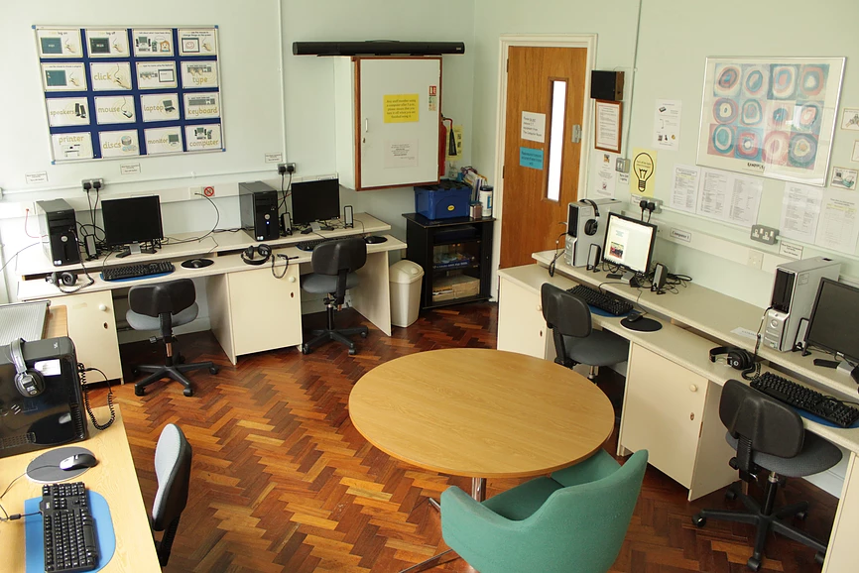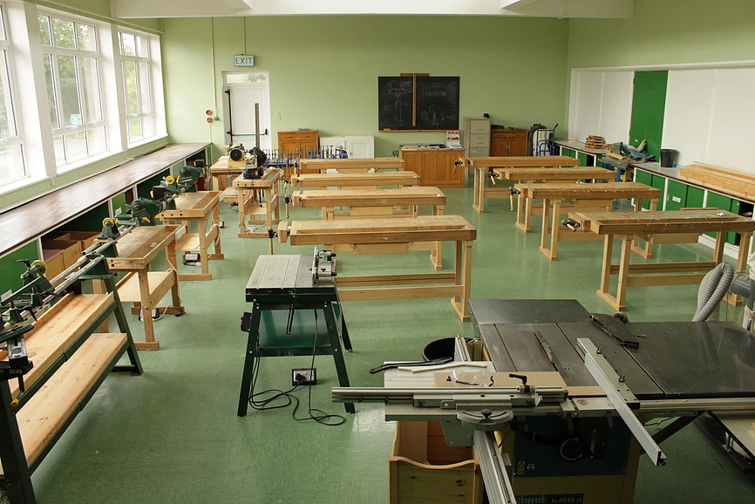
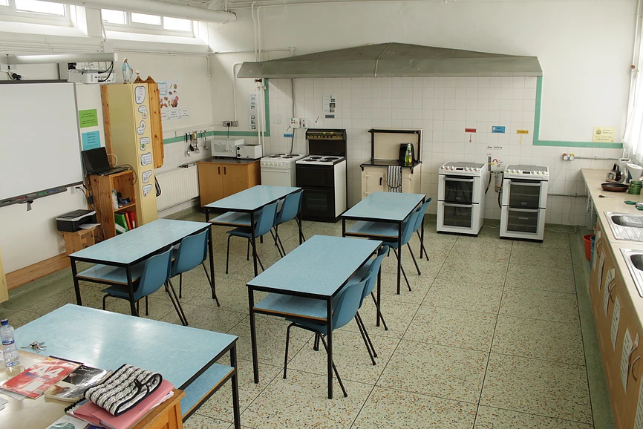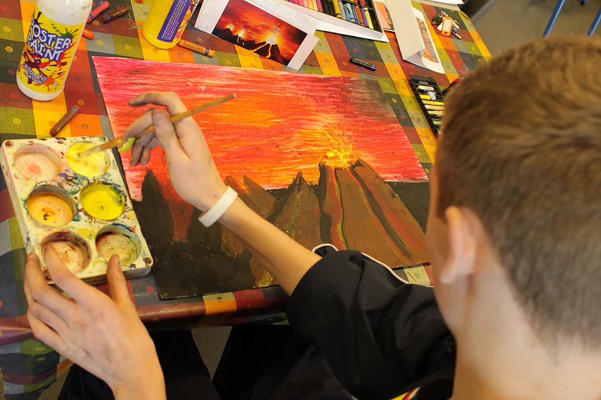

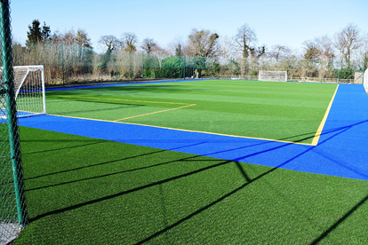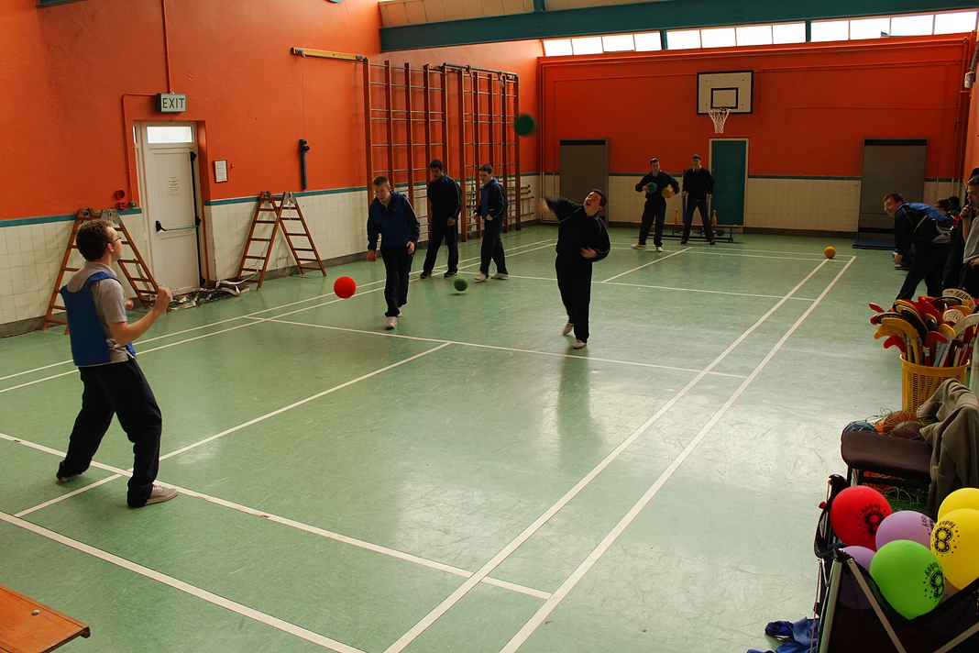
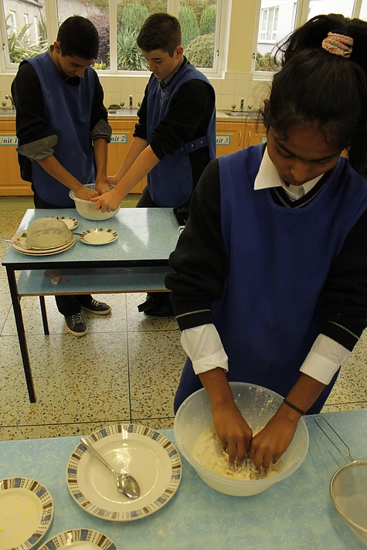
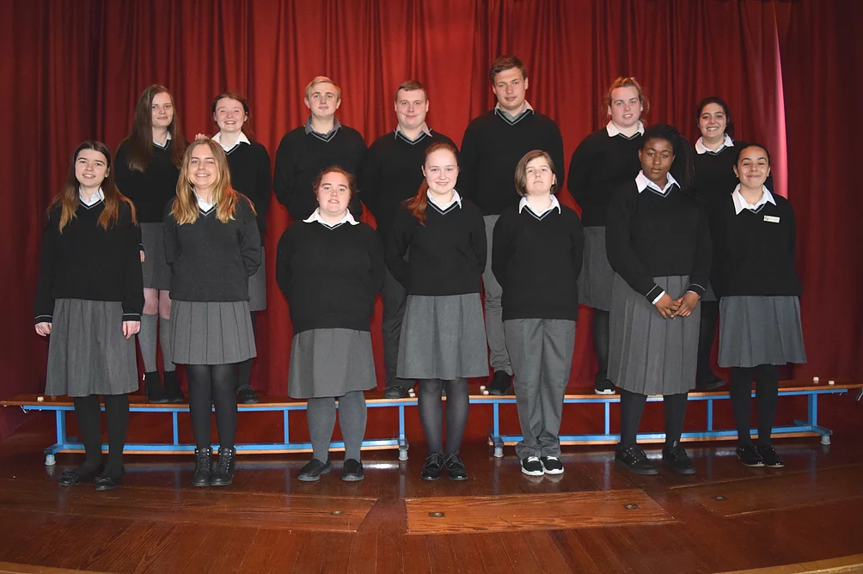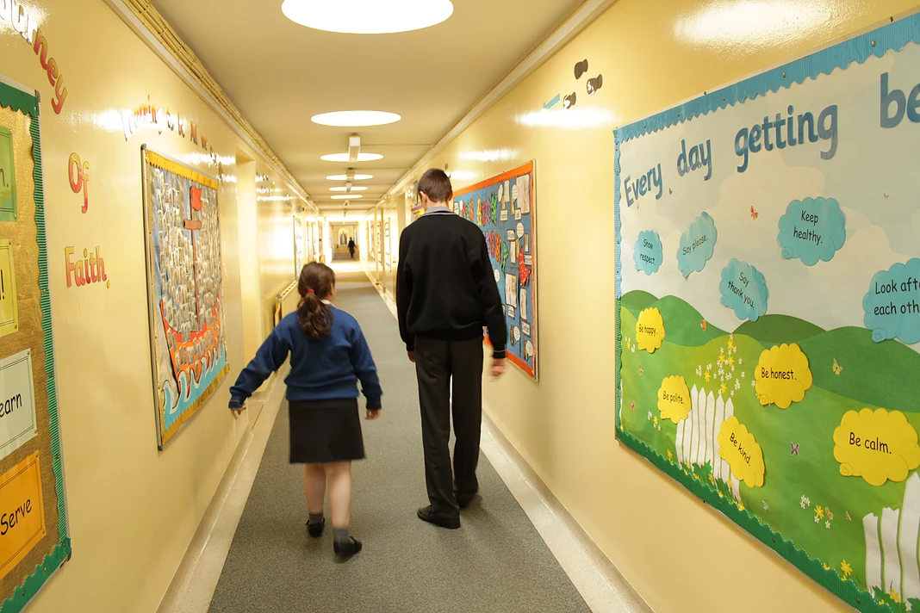
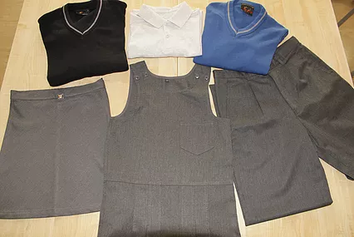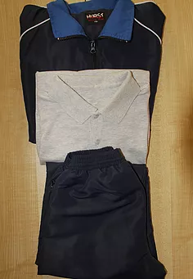

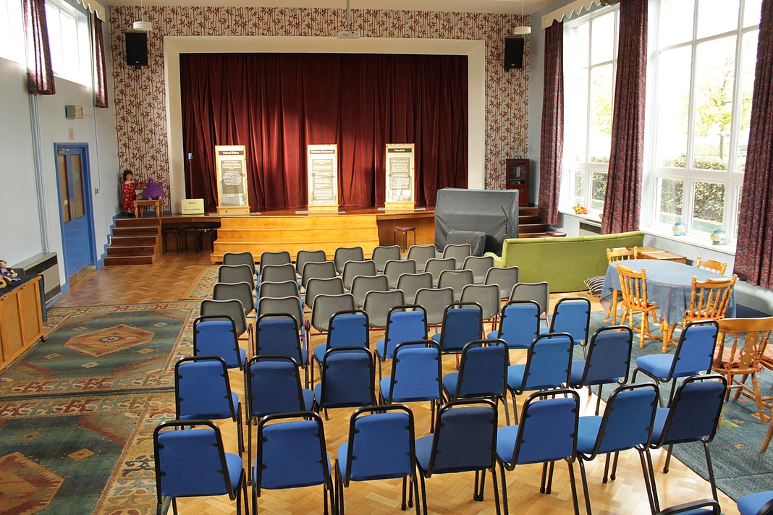

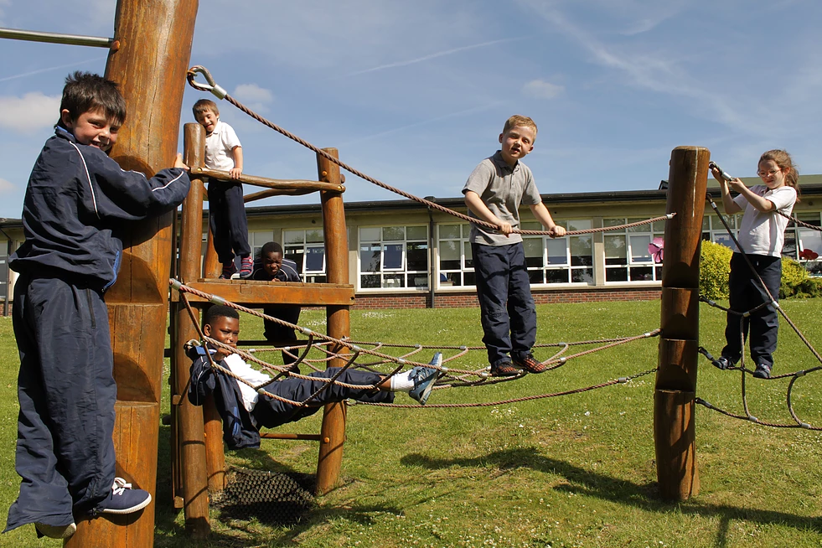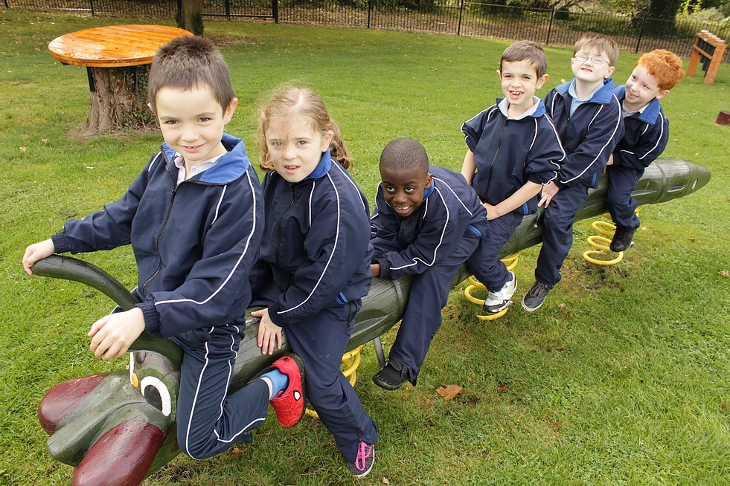
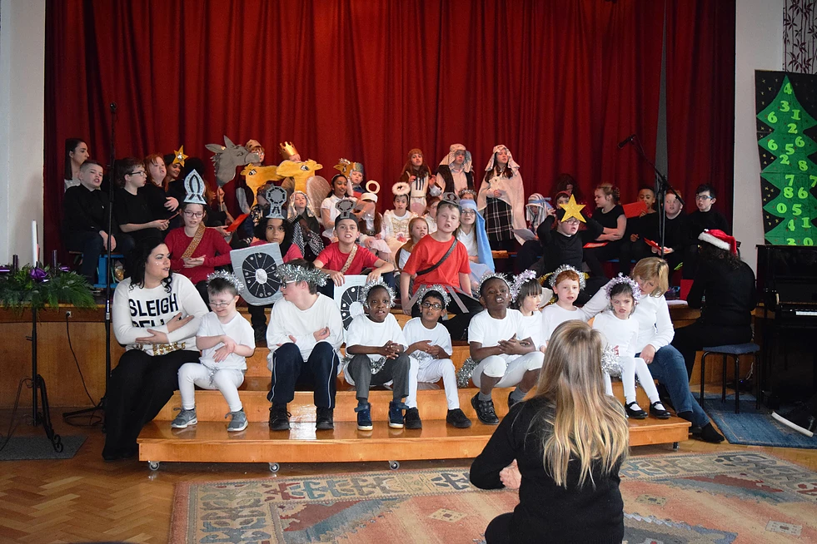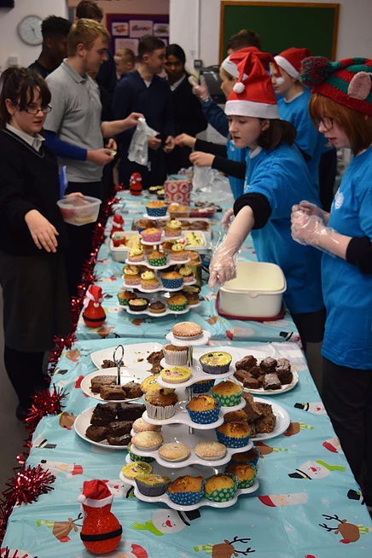

Mr Toomey
Referrals:
St. Michael's School accepts referrals from:
(a) Parents/Guardians.
(b) Other relevant agencies, as may be applicable, with parental consent.
- The Board of Management requests parents/ guardians and /or referring agencies to inform the School if application has been made for placement in another school.
- The recommendation by a psychologist should be for a school designated for pupils with a Mild General Learning Disability as identified by their Full Scale IQ.

When considering St. Michael's School as an option, parents/guardians must:
- Be willing to allow their child to meet with the School Principal / Deputy Principal and/or relevant members of staff,
- Visit the School prior to their child's admission,
- Show a willingness to accept special school placement,
- Give permission, where appropriate, to the School Principal or delegate to visit the school presently attended by the child,
- Give permission, where appropriate to contact/meet with any relevant Multidisciplinary Team members that may be associated with their child,
- Allow and accept appropriate placement by the School Principal within the class setting.

Enrolment Criteria
An Admissions Team assess each application for enrolment. Generally, recommendations are made to the Board of Management giving consideration to the following criteria:
- Pupils of school-going age who, on psychological testing, are found to be functioning within the level of mild general learning disability. Full Scale IQ and Standard Scores must be provided.
- Pupils who, on psychological testing, are found to be of mild/borderline ability and who, in addition, have other significant needs, e.g. language delay, speech impairment. All original reports of diagnosis to be provided at the time of application.
- Pupils with a mild general learning disability and an associated difficulty, e.g. Autistic Spectrum Disorder. All original reports of diagnosis to be provided at the time of application.
- Pupils of all religious denominations within the level of mild general learning disability.
- In order for transport to be sanctioned, the pupil, on psychological testing, must have a definite diagnosis of mild general learning disability based on their Full Scale IQ and a specific recommendation for a special school placement.
- In the event of Special Needs Assistant support being required, a specific recommendation for Special Needs Assistant support within a special school setting must be made in the psychological assessment.
- In the event of Bus Escort support being required, a specific recommendation for Bus Escort support whilst on school transport services must be made in the psychological assessment.
- Broadly speaking, pupils attending St. Michael's School come from the catchment area which should be the nearest school to their address for pupils with a mild general learning disability and is basically defined by provision of transport sanctioned by the Special Educational Needs Organiser (SENO), the Department of Education & Skills and organised by School Transport Services, Bus Eireann.
- Availability of a place in an age appropriate class.
- Pupils whom the Admission’s Team otherwise recommend for admission for stated reasons.

- The closing date for referrals for September enrolment is January 10th of that year. Applications will be accepted from September 1st of the previous year.
- Late applicants will not be processed/considered unless places become available when all timely applications have been processed. Parents/guardians are welcome to re-apply for the following year in Septembe

The Board of Management of St. Michael’s School will consider applications for places for pupils with disabilities such as physical or sensory disability, Autism Spectrum Disorder, Attention Deficit Disorder, Attention Deficit Hyperactivity Disorder, Oppositional Defiance Disorder, any other recognised disorder that can co-occur with a Mild or Borderline General Learning Disability provided that they are secondary to a primary disability of Mild or Borderline Mild General Learning Disability.
It is not a school that caters for pupils with emotional and behavioural difficulties.

Mr Toomey

Application Procedure
The parent/guardian/referring agency must apply in writing to the school, furnishing the following documentation to the School Principal and satisfying the above criteria:
  - Recent Psychological Assessment containing a definite diagnosis of Mild General Learning Disability indicated with FSIQ standard scores (within two years of report),
  - A recommendation within this report for a school for pupils with a Mild General Learning Disability,
  - Copies of any other reports containing original additional diagnosis, e.g. ASD, ADHD etc.,
  - Social History (where appropriate),
  - Medical Report (where applicable),
  - Psychiatric Assessment (where appropriate),
  - Speech and Language Therapy Report (where applicable),
  - Previous School Reports/Individual Education Plans,
  - Any other relevant information.

An application will not be deemed completed until all documentation has been received. An appointment to visit the school will be made on receipt of all relevant documentation. Parents/Guardians of applicants who do not meet the criteria as set out in this policy will be notified in writing.
Upon receipt of documentation indicating that the child meets the criteria for enrolment, groups of parents/guardians are invited in to a general information meeting with the Admissions Team. If any other person is attending this meeting with parents/guardians, the school must be informed in advance. At this meeting information about St. Michael’s School, the Curriculum, Ethos, etc. will be shared and small groups of parents/guardians will be escorted on a brief tour of the school.
If parents/guardians wish to proceed with the application for enrolment, this must be expressed in writing to the Principal. An arrangement will then be made for the Admissions Team to meet with the parent/guardian and child with a view to possible enrolment. If any other person wishes to attend this meeting with parents/guardians, the school must be informed in advance and, where considered appropriate, this will be accommodated. A record of all meetings and decisions of the Admissions Team will be kept.
Prior to actual admission the following certificates are required:
- Birth Certificate,
- Baptismal Certificate (if applicable).

