Mr Toomey
St. John of God Special School
Islandbridge
Dublin 8
Eircode: D08 P89W
Phone: 01 6741534
Email: INFO@STJOHNOFGODSCHOOL.COM
Website: stjohnofgodschool.com
Facebook: www.facebook.com/sjogparents/
Principal: Marie Ryan

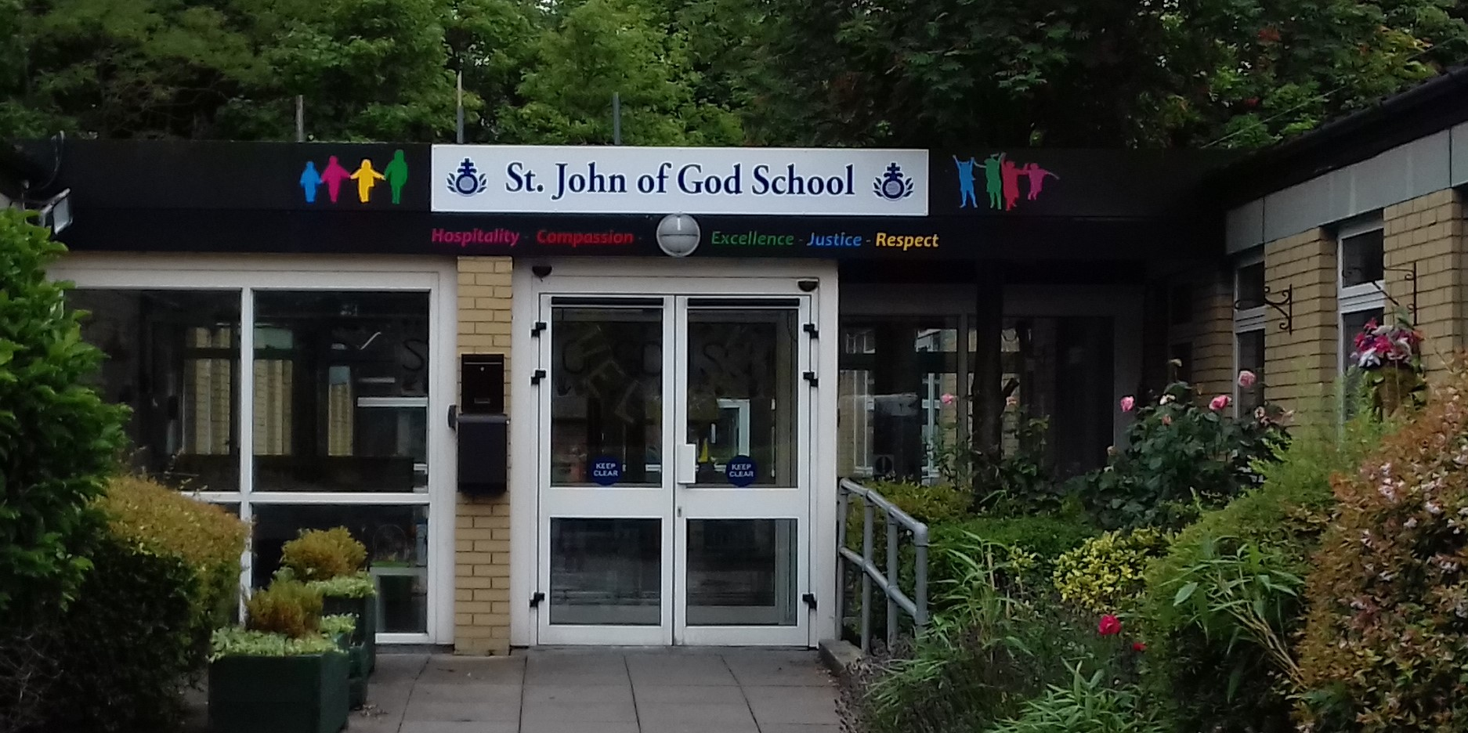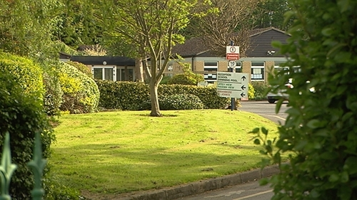

School for: Moderate general learning disabilities (GLD).
Two additional classes are designated for students with Severe/Profound GLD
There is one class for students with Autistic Spectrum Disorder (ASD) who also have
Moderate GLD.

Mr Toomey
General Information:
- St. John of God School, Islandbridge is a co-educational special school.
- The school provides education for pupils between four and eighteen years of age with
moderate general learning disabilities (GLD).
- Two additional classes are designated for students with Severe/Profound GLD
- There is one class for students with Autistic Spectrum Disorder (ASD) who also have
Moderate GLD.
- The school is not a therapeutic school for pupils with significant emotional and
- behaviour difficulties.
- The school has limited access to a Multi-Disciplinary Team. (Speech & Lang Therapist, Occupational Therapist)
- The school welcomes referrals for enrolment of any pupil who, on assessment, is
functioning within the above range of learning disability and that this learning disability
is her/his primary special educational need.
- The school provides an educational service to children residing mainly in the Local
Health Office Areas 3, 4, & 5.
- All pupils of St. John of God School, Islandbridge, are entitled to transport to and from school each day.
- The students take part in the Dolphin Swim School Programme which operates in the school swimming pool.
- 89 students in the school.
- Staffing includes the principal, sixteen teaching posts and thirty special-needs
assistants
- Pupils are skilfully supported in developing language and communication skills, through the use of oral language, augmentative approaches, such as manual signing for people with disabilities (LÁMH), gestures, pictures, and the Picture Exchange Communication System (PECS)
- The school has recently introduced the School Wide Positive Behaviour Support
(SWPBS) system to support the management of behaviour across the school
- Pupils have opportunities to attend and engage in the areas of personal care and well-being, and in being part of a community, in and beyond the school.
- Some of the School subjects are, English, Maths, ICT, Home Economics, Visual Arts, Drama, Music -Choir & band, PE, dance and gardening
- The senior pupils in the school leavers’ have work experiences in local businesses and services.
- The students can access to the Junior Certificate Level 1 and Level 2 programmes.
- Whole School Evaluation in 2017 – Very positive
- The school is participating in the In-School Therapy Demonstration Model.

- Students can make their Communion and Confirmation in the school
- 8 classrooms were recently updated with new interactive screens.
- 35 iPads were purchased and there is now at least 2 iPads in each classroom
- Teaching is done thematically each month.

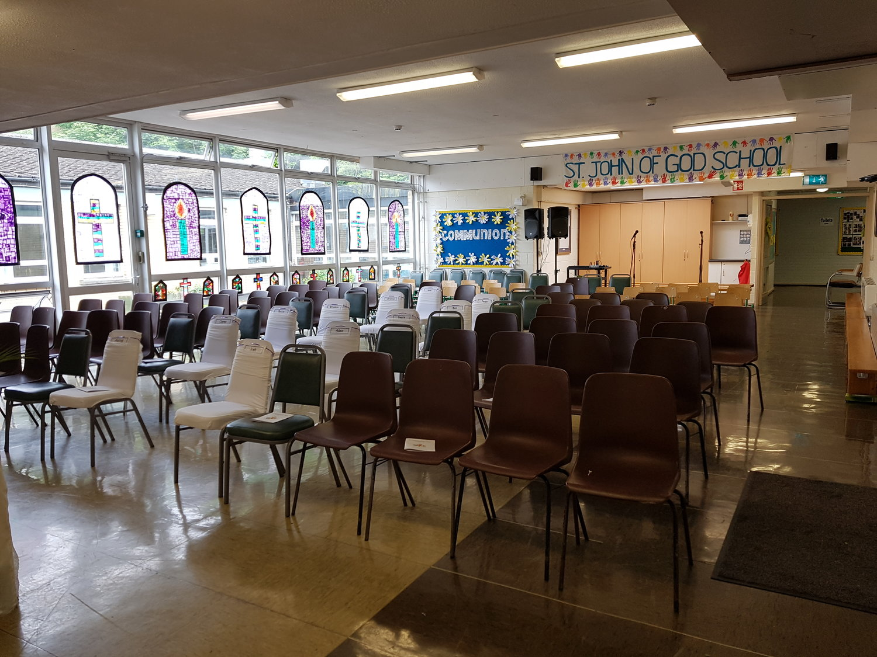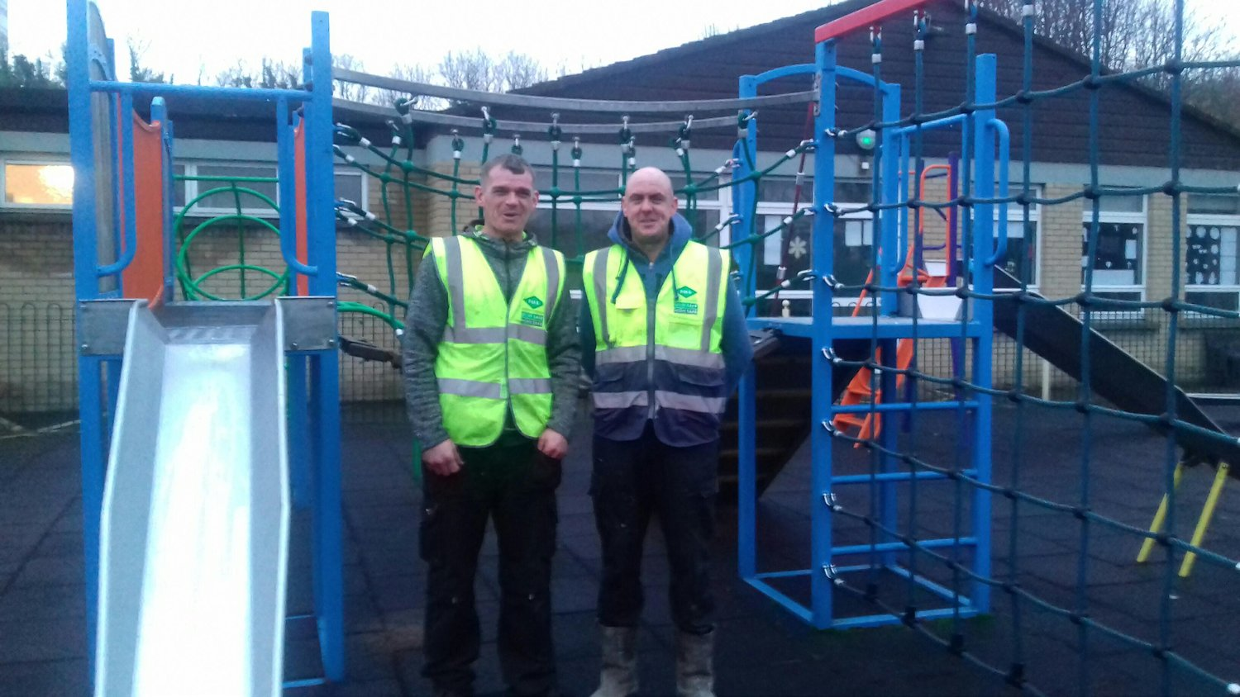
School Hall Playground
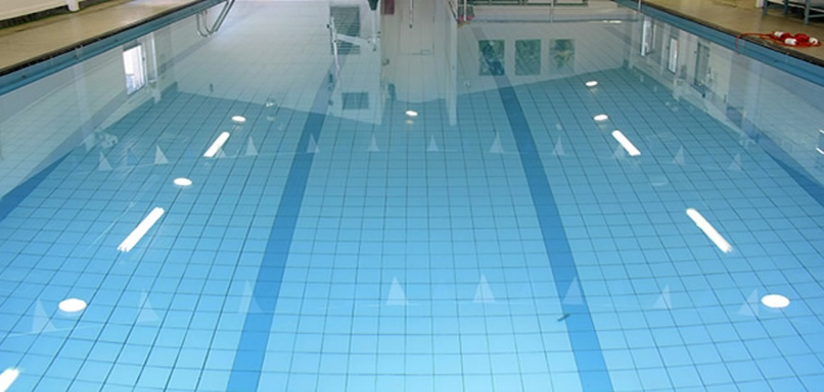
swimming pool

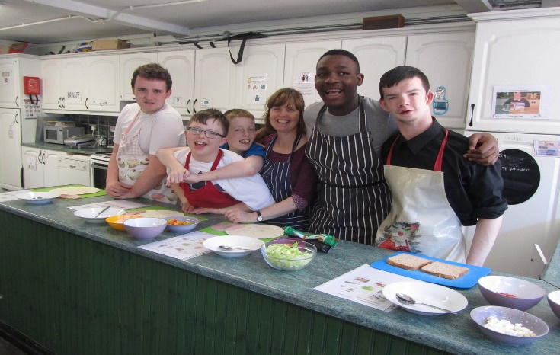
Mr Toomey

Cooking

Cookery classes in the school is for with pupils from Class M2 to the School Leavers.
They enjoy one session of cookery each week. Our cookery room is equipped so that it resembles a homely kitchen. We make a wide range of dishes using and re-using
similar ingredients which are easily found in most fridges and kitchen cupboards.
This is so that the pupils will be able to continue their cookery skills at home.

Out and About Programme

The Senior Classes in the School, from M2 to the School Leavers participate in the
Out & About Programme in our School. This programme is key to the independence
and confidence of our students when they leave school.

The programme begins with our students attending the Staff Canteen to learn how
to make tea, sit and chat socially and tidy up after themselves.
They learn how to identify coins and the steps involved in using the vending
machines.

The classes go out and about to learn how to be good pedestrians and how to cross
the road safely.
They buy items in a nearby shop; looking after their money, queuing appropriately, paying properly and engaging the staff when they need assistance.

Over the years, the student’s progress to walking to nearby cafés and reading the
menus and managing their money by saving in the Post Office.
The classes begin going to town on the bus and visit various restaurants to practise reading different menus.
The students engage in personal exercises such as getting their feet measured,
learning their coat sizes, making appointments in the hairdressers before they go to
the Debs Ball!
They shop for groceries in Tesco for their weekly cookery class.
They save in the Post Office and budget when shopping for Christmas presents for
their families.

Mr Toomey

Referral Procedure 2019
- Parents can refer their son/daughter to St. John of God School. If a third party, acting on behalf of a parents, refer a child to our school, it is expected that it is with the parents agreement. The person referring the child is the person the school will enter into correspondence with.
- Parents should email the school at info@stjohnofgodschool.com to request the application form. This completed application and psychological forms should be returned to the school before the application deadline.
- Applications are processed during the academic year prior to enrolment. In order to allow sufficient time for appropriate assessments to be completed and reviewed the referral timeframe is as follows: 1st September to 28th February of the same academic year for the following school year. All complete applications are time and date stamped when received. Complete applications will be evaluated based on the selection criteria outlined below. Referrals received after February 28th will only be accepted and processed if the school has capacity.
- Each year, the Principal will establish how many pupils with moderate/ severe & profound/ ASD & Moderate GLD are leaving the school. This will then determine how many places are available to new applicants.
- From September 1st each year, St. John of God School accepts new referrals for the following school year.
- Unsuccessful applications are not placed on a waiting list for enrolment in future years. They form the basis of an oversubscribed list that the school refers to if places become available during that current school year only.
- Unsuccessful applications and accompanying documentation are stored and destroyed
in line with General Data Protection Regulation (GDPR).
- Parents and professionals wishing to enrol a student in the school should forward a
letter of referral accompanied by the most recent Psychological Assessment (recommending Special School placement) and previous school report and the
completed application form. Other relevant clinical reports such as Speech and Language, Physiotherapy, Psychiatric, Occupational Therapy etc. should also be provided, if available. The referral letter should be addressed to: info@stjohnofgodschool.com
or The Principal, St. John of God School, Islandbridge, Dublin 8, D08 P89W.
- Receipt of Applications will be acknowledged by the school within 21 days of receipt of application.
- This acknowledgement does not infer an offer of a place in the school.
- A copy of the school’s Enrolment Policy is available on the School Website.

Criteria for Acceptance
All applicants will be evaluated using the following criteria:
- That the applicant meets the profile of the school.
- That appropriate documentation is supplied and an honest account is given regarding
the needs of the child to enable the school to make a decision.
- That there is place in the school appropriate to the age and/or disability category of the applicant. In the event of a category being oversubscribed, priority will decided by date of receipt of completed application.
- That the applicant’s medical needs can be safely managed by staff.
- That Parents/Guardians of successful applicant are willing to engage with the school by signing relevant School Policies e.g. Code of Behaviour, Health and Safety and Behaviour Management Policies.
- That the Health and Safety needs/rights of the applicant and/or other pupils are not compromised.
- That the school has capacity to provide for the needs of the applicant in the light of the necessary resources available to it.

Selection Procedure
- All applications are assessed by the Admissions Advisory Team based on the criteria outlined above. The Admissions Advisory Team is approved by the Board of
Management and consists of the Principal, Deputy Principal and Senior Post Holder within the school. Occasionally the team request the professional advice of the Psychologist, Menni Services and/or St. John of God Education Officer. The Principal
may at times consult with and seek the advice of the Special Educational Needs
Organiser (SENO) and the School Inspector. The team discuss each referral and the accompanying reports to determine the eligibility and needs of the prospective students. Following this, the team prepare a report to present to the Board of Management (B.O.M) for discussion at the next B.O.M. meeting.
- Parents are welcome and encouraged to visit the school with their child. This does not infer an offer of a place in our school.
- The school Principal or a member of the Admissions Team meets with prospective students and parents/guardians. It is good practice to complete all National Council for Special Education (NCSE) forms at this stage (see Appendix A)
- On receipt of all the relevant reports and on completion of necessary meetings/visits, a decision will then be made by the Board of Management as to the suitability of St. John of God School, Islandbridge for the prospective pupil.
- Final decisions in relation to all applications are made by the Board of Management.
- A letter of offer, signed by the Chairperson, is forwarded to the parent/guardian of the applicant on behalf of the B.O.M.

- Parents are asked to complete the following
  - School Acceptance Form.
  - School Enrolment Information Form.
  - NCSE Transport Form.
  - NCSE SNA (abbreviation, need to state in full?) Form.
  - Medical Protocol Form.
  - Relevant Policies (see policies listed below Appendix B)
- We endeavour to ensure that each pupil has a positive and successful experience at our school. For some pupils, a part time placement that increases incrementally to a full day/ week, may be in their best interest. If it is felt this is necessary to ease the new student into the school community, it will be agreed with parents in advance. The criteria for demonstration that the student is ready for an increase in the length of their day will be agreed by the class teacher and parents.
- All new pupils on their first day in the school are entered on the Primary Online
Database (POD) and a letter is sent to their previous school (Appendix C)

Right to Appeal
- Where an application is not successful, the parent or guardian will be advised of their right to appeal to the Chairperson, Board of Management, St. John of God School in the first instance. This in no way affects their rights under Section 29 of the Education Act 1998.

Admission Date
- Normally admission to the school will occur within the first week of the new academic school year. Admission at any other time throughout the school year will be at the discretion of the Board of Management.

Suspension/Expulsion
- In accordance with the terms and conditions laid down by the Education (Welfare) Act 2000, Section 23.2, a child may be suspended or expelled. This action will only be taken where there is no alternative and where the safety of students and/or staff is at risk.
The regulations of the National Educational Welfare Board will be followed at all times.

Policy Revision
- It is recognised that this enrolment policy may need to be revised/modified from time to time in the light of ongoing evaluation of new approaches and the implications of relevant future enrolment. This report was amended by Board of Management on 23 August 2019

Procedures for requesting supports from the National Council for Special Education (NCSE)

- An important element of the Enrolment Process in St. John of God School, Islandbridge is to ascertain the individual needs of each student and what supports are required to be in place prior to commencing in school.

- The NCSE is the agency empowered to sanction supports in all areas of special education: SNA Support, School Transport and Assistive Technology. All requests to the NCSE are required to have the signatures of the Principal and the Parents / Guardians. Responses to these requests often take months.

- I consider it to be in everyone’s best interests if you could consider signing the relevant request form / forms today which you think may be required or helpful to the young person seeking enrolment in St. John of God School, Islandbridge. In addition to signing the request forms please also submit any documentary evidence you may have to support the request forms. This will result in the school being in a position to forward the relevant request forms to the NCSE immediately following the decision of the Board of Management to offer a place. This, in turn, will improve the chances of having transport, SNA support, etc. in place prior to attending on the first day.

- Please remember that signing these forms does not guarantee a place in the school. Neither does it guarantee that your request will be granted by the NCSE. However, we do guarantee that you will be informed of any supports we are successful in securing.

The school was recently donated a Cubbie.
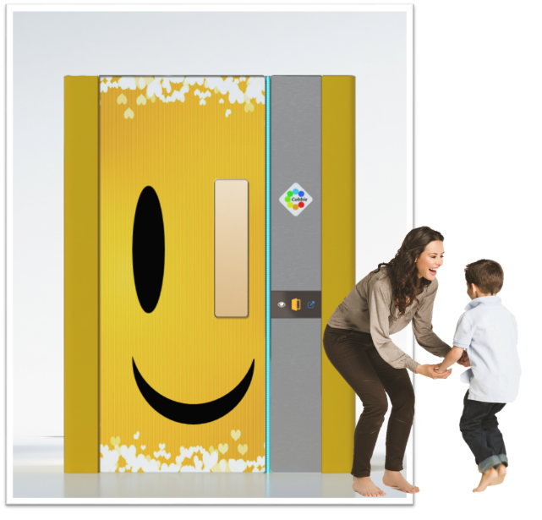
Cubbie is a new innovation providing safe, comfortable and adaptable environments for people with
a disability and special needs.
The unique cubicle design is wheelchair and hoist accessible and can be seamlessly integrated onto any
floor/area where space is at a premium.
It is a calming sensory environment for pupils and has a personalised sensory management system.
The Cubbie was created to provide a safe space that was comfortable for all levels of sensory need. Sensory
rooms provide relief for only one sensory type and can cause sensory overload. Our system provides
options and relief for all sensory types. We purposefully avoided using lots of colourful patterns and
moving lights/objects in the design. These can be very distracting and overwhelming for the person.
Instead, we designed a blank canvass which can be uniquely altered to the persons need.
Our Occupational Therapist designs a sensory program for each person, this is delivered within the
Cubbie sing lights, images, sounds and other senses which are all controlled with our user-friendly
software.

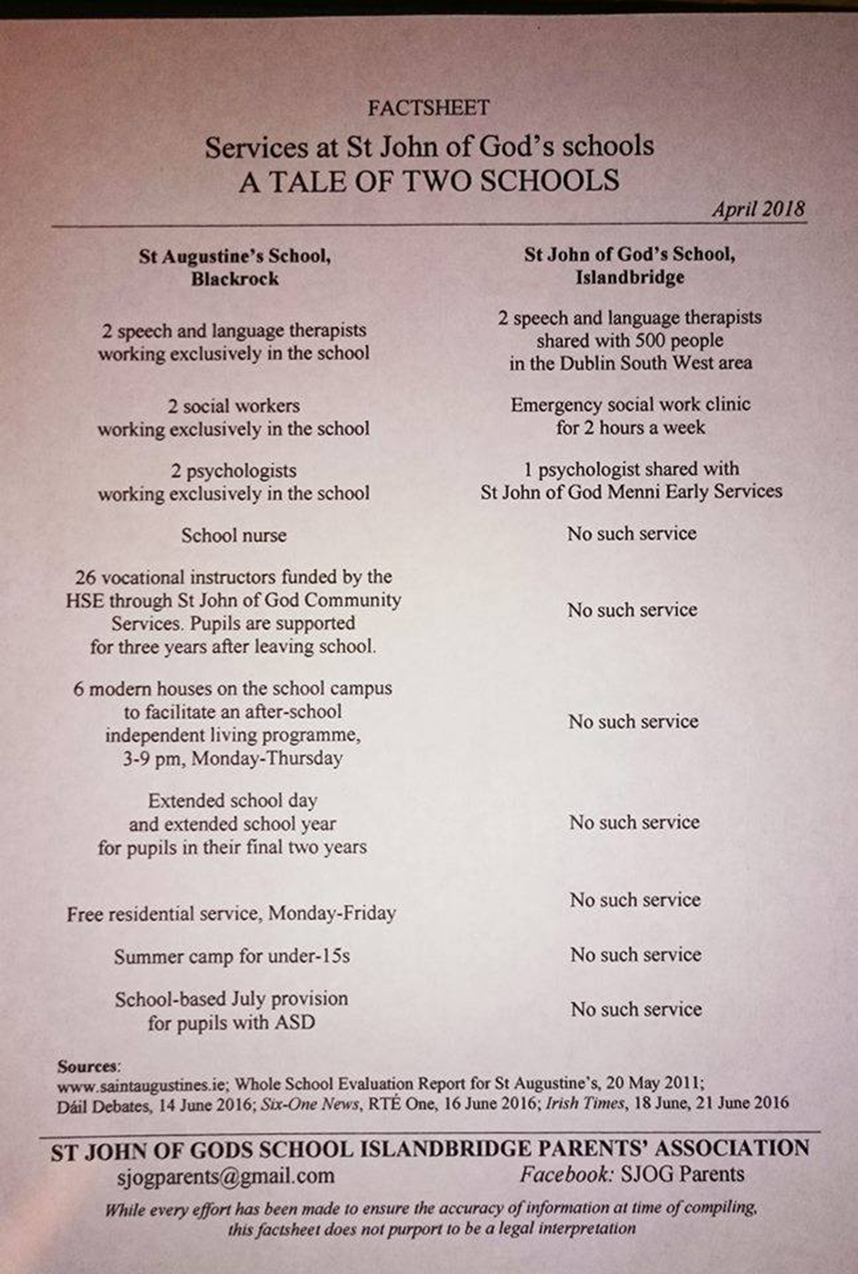

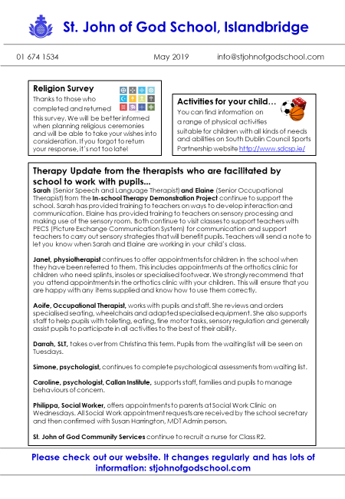
Access to these services one day a week.

