Mr Toomey
St. Joseph’s Special School
Balrothery
Tallaght
Dublin 24
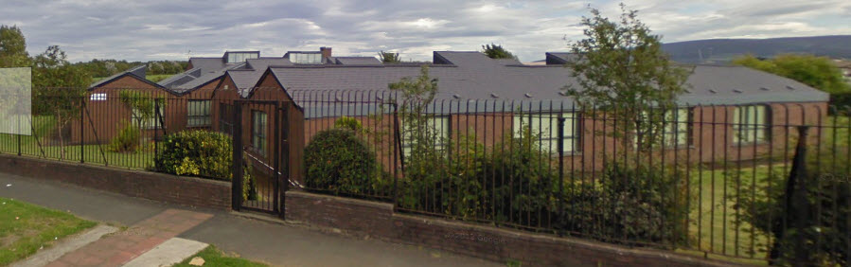

Ph: 01 4515961
Email: admin@sjss.ie
Facebook: www.facebook.com/StJosephsSpecialSchool
Principal: Graeme Crombie

Mild general learning disability School
It also caters for pupils with a diagnosis of ASD.
Children with additional needs which include Speech and Language, Physical and Sensory Disabilities with a mild general learning disability will be eligible for consideration.

Mr Toomey
About us:
  - St Joseph’s is a co-educational special school catering for pupils with a mild general learning disability.
  - It also caters for pupils with a diagnosis of ASD.
  - At present there are 87 pupils on roll.
  - It caters for pupils aged 4-18 years of age.
  - Children with additional needs which include Speech and Language, Physical and Sensory Disabilities with a mild general learning disability will be eligible for consideration.
  - St. Joseph’s School is not designated, resourced or staffed to meet other specific needs of pupils which may include the following
    - Children with moderate to severe emotional behavioural difficulties
    - Children with high medical needs
    - Children in the moderate – severe intellectual disability range
  - We have four classes for pupils with ASD.
  - In these classes the ratio of pupils is six to one teacher and two/three SNAS.
  - We have three primary classes and five post-primary classes.
  - Primary classes are offered the full mainstream curriculum.
  - We offer the Junior Certificate and LCA programmes at post-primary level.
  - Pupils partake in swimming and a range of sporting activities.
  - We have weekly assemblies where pupil achievements and the latest news is shared with the whole school community.
  - Teachers meet with parents to discuss the child’s individual education plan (IEP) at the end of September and then it is reviewed in March
  - St. Joseph’s provides services for those living in Tallaght and surrounding areas. Referrals for entry to the school are considered on a case by case basis.
  - Children in surrounding areas will be considered for transport to and from the school.
  - Referrals must include a recent psychological report (assessed within the last 2 years)
  - Referrals for a September enrolment must be submitted before March 1st.

Mr Toomey
Our commitment to each child will be:
  - To foster and encourage involvement by the pupil in all aspects of school life and school routines
  - To support the child’s social independence and the development of friendships with peers
  - To support the development of play skills
  - To foster and expect age-appropriate, socially acceptable behaviour at all times
  - To provide access to all areas of the curriculum at a level appropriate to the individual child
  - To recognise the importance of teaching reading and writing daily, to develop speech, language and working memory skills as well as numeracy skills
  - To facilitate independent learning and the ability to work and learn as part of a group

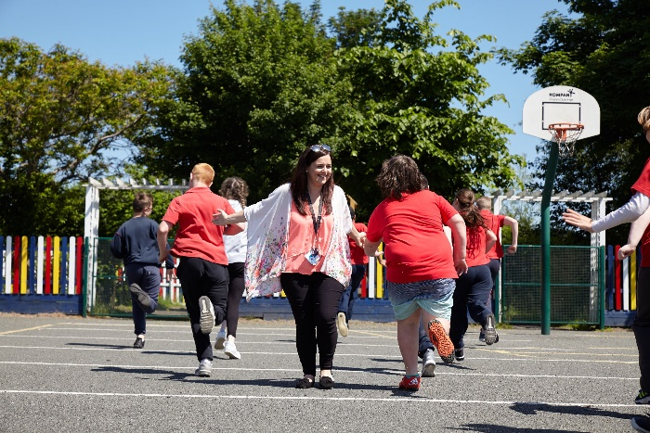

Mr Toomey

The ASD Special Classes uses the methodologies of:
    - ABA (a scientific discipline concerned with applying techniques based upon the principles of learning to change behaviour of social significance)
    - TEACCH (Treatment and Education of Autistic and Communication related handicapped CHildren) is an evidence-based service, training, and research program for individuals of all ages and skill levels with autism spectrum disorders. TEACCH is centred on five basic principles. First, physical structure refers to individual’s immediate surroundings. Daily activities, such as playing and eating, work best when they are clearly defined by physical boundaries. Second, having a consistent schedule is possible through various mediums, such as drawings and photographs. Third, the work system establishes expectations and activity measurements that promote independence. Ideal work systems will communicate objectives with minimum written instructions. Fourth, routine is essential because the most important functional support for autistic individuals is consistency. Fifth, visual structure involves visually-based cues for reminders and instruction)
    - PECS (The Picture Exchange Communication System, or PECS, allows people with little or no communication abilities to communicate using pictures. People using PECS are taught to approach another person and give them a picture of a desired item in exchange for that item.
    - Lámh (Lámh is the manual sign system used by children and adults with intellectual disability and communication needs in Ireland. With Lámh, speech is always used with signs and only key words in a sentence are signed.)
