**Illuminated Letters**

An illuminated letter is usually the first letter of a page or paragraph in a historic, handwritten text. It is always enlarged and coloured richly with gold applied in some areas.

You will need:

A4 or A5 (half of A4) plain paper

A pencil

Coloured pencils, pens or paint

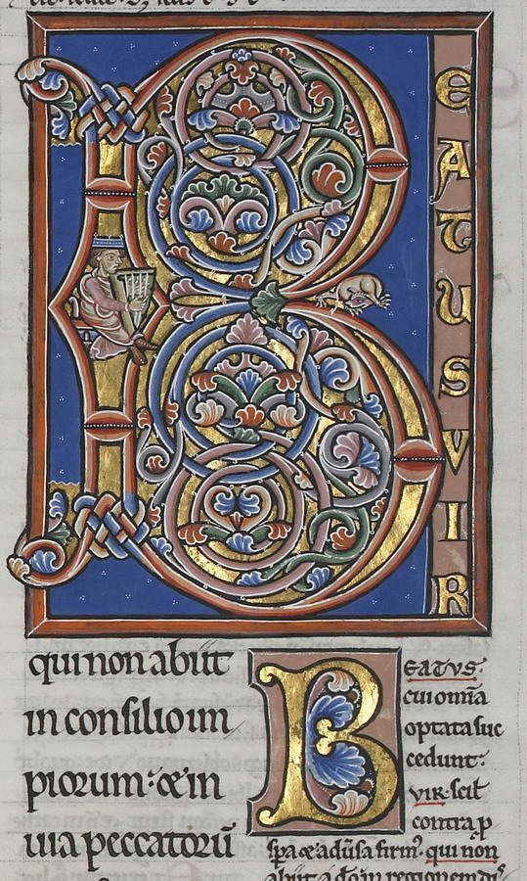

Step 2: Use a drawing pencil to draw your letter on paper. Remember you should aim to fill most of the page. If your letter has a straight edge, you could use a ruler. Then draw around your line letter to make a bubble letter.

a) b)

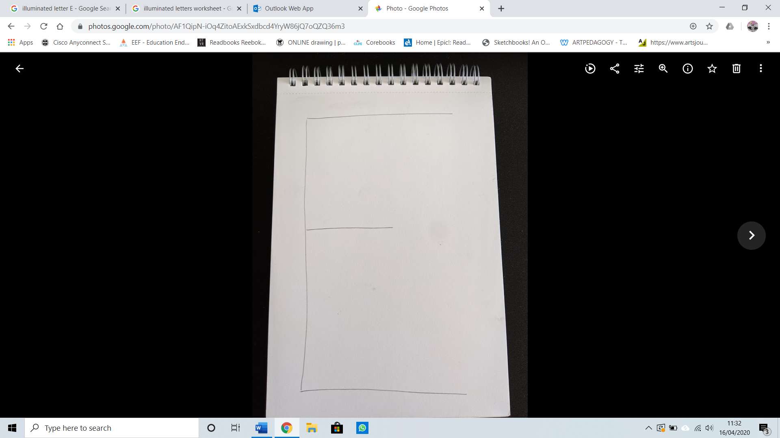

How to create your own

Step 1: Collect some design ideas. Most traditional illuminated letters have flowers, plants or animals on and some tell religious stories. But you can create any design you want. You could take inspiration from your favourite sport, game or book. You could even use the pattern from your curtains or on your bed sheets! On the second instruction page there are some more ideas.

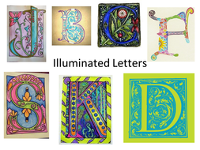

Step 3: Colour your letter with either coloured pencils, felt tip or paints. You can use a mixture of the different materials.

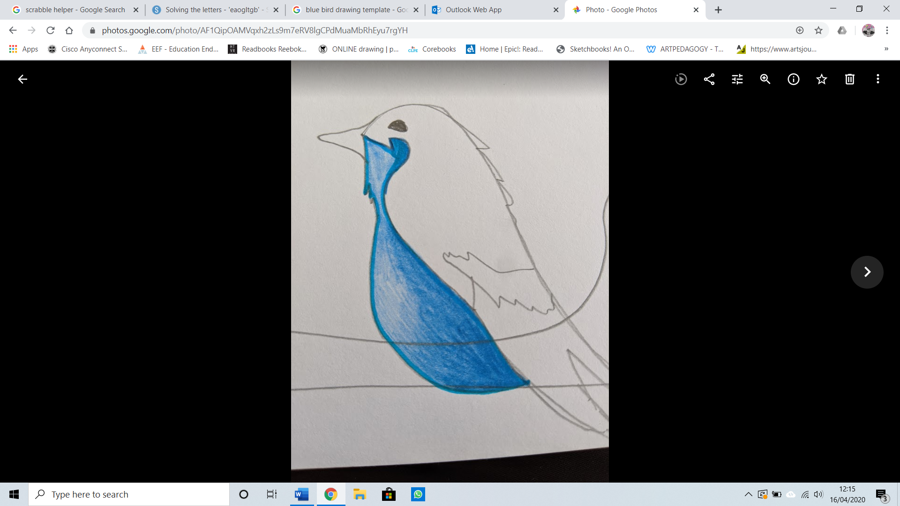

Step 4: You could outline some or all your piece. This could make your images stand out from each other. You can use any pen such as a biro and it does not have to be black.

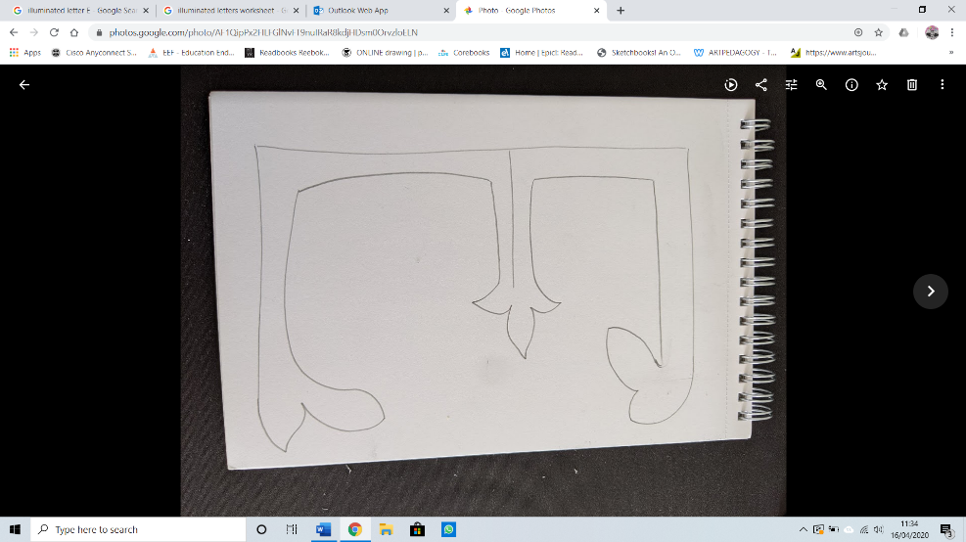

|  |  |  |
| --- | --- | --- |
| Illuminated Letters A Printable <b>illuminated</b> manuscript <b ... | DRAGON LETTER S FROM THE WINCHESTER BIBLE. Illumination by Tania ... | GRADE 5 | Illuminated letters, Alphabet art, Fancy letters |
| Mary Teichman Calligraphy & Illuminated Letters | Illuminated Letters | siberspace | Letterfest 2017 – Portland Society for Calligraphy |
| Illuminated Manuscripts - Lessons - Tes Teach | 6th Grade Illuminated Letter | Modern contemporary illuminated letter from story book C ... |