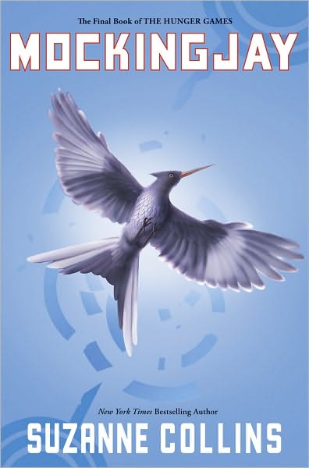
Review Of Mockingjay:

Summary: Katniss has survived the Hunger Games once again, but a revolution is starting. She must take her place as the Mockingjay for her people. How long will the girl on fire survive? Every flame has to burn out eventually.
Review: As I started reading the book it got me very interested. What started as a simple story line turned into a book full of plot twists and action. One flaw I saw in the book was the last 50+ pages, left me quite bored to say the least. Overall the series is great and gets you thinking. There is great character development and it is very well written.
After reading the entire series I give it eight stars out of ten. Mockingjay alone gets six stars out of ten since the last half of the book left me unentertained.
The movie is expected to come out in 2014 but will be split into two parts just like Harry Potter and the Deathly Hallows. All I have left to say about the book is keep tissues nearby.
By Magdalena Mroczek

