CLONBURRIS N.S. RETURN TO SCHOOOL - ENTRANCE AND EXIT ROUTES

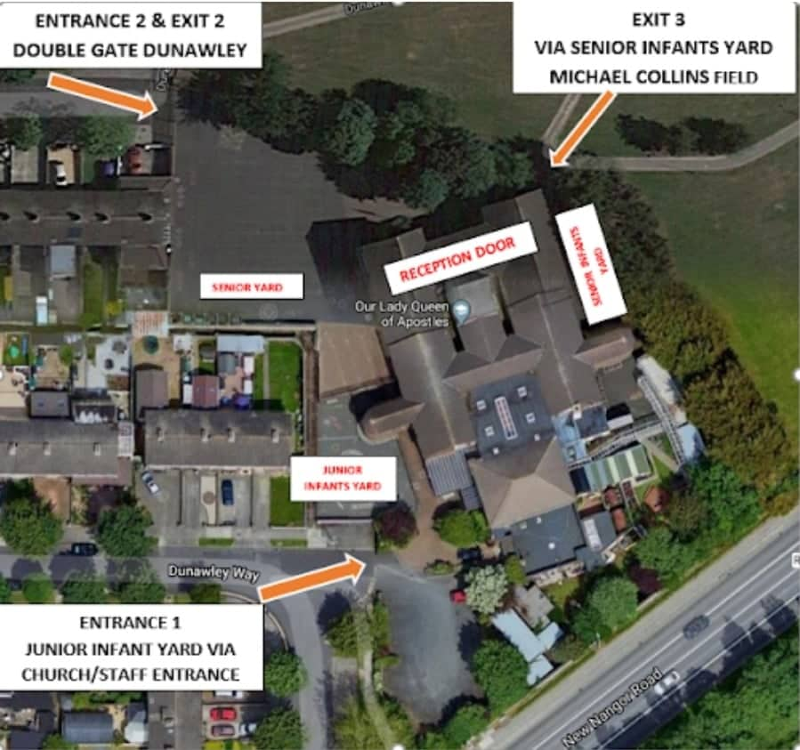

** PLEASE REFER TO THE ‘BACK TO SCHOOL TIMETABLE’ FOR START AND FINISH TIMES **
ENTRANCE 1 JUNIOR INFANT YARD VIA GATE FOR CHURCH/STAFF ENTRANCE:
THIS ENTRANCE IS USED FOR JUNIOR INFANTS AND SENIOR INFANTS IN THE MORNING
ENTRANCE 2: MAIN GATE DUNAWLEY:
BOTH GATES WILL BE OPEN AND THIS ENTRANCE IS USED FOR
1stCLASS, 2ND CLASS, 3RD CLASS & 5TH CLASS
EXIT 2 MAIN GATE DUNAWLEY:
JUNIOR INFANTS, SENIOR INFANTS, 1ST CLASS, 2ND CLASS,3RD CLASS AND 5TH CLASS USE THIS
EXIT 3 VIA SENIOR INFANTS YARD AND MICHAEL COLLINS FIELD:
4TH AND 6TH CLASS BOTH TO USE THIS EXIT

PLEASE NOTE THE FOLLOWING:
- GATES WILL NOT OPEN UNTIL 08:45 - WE ASK THAT NO CHILD BE DROPPED OFF OR LEFT AT THE SCHOOL GATES UNTIL THEIR DESIGNATED TIME AT THEIR DESIGNATED ENTRANCE
DROP AND GO COLLECT AND GO
- MS MORLEY and MS LANIGAN WILL BE STANDING AT THE SENIOR YARD GATE IN THE MORNING AND WILL DIRECT CHILDREN TO THEIR LINES AND HELP ANY LATE COMERS OR PUPILS WHO MISS THEIR LINE
- MS M CAROLAN AND OTHER STAFF WILL BE AT THE ENTRANCE FOR INFANTS
- STUDENTS WILL BE COLLECTED FROM THE YARD BY THEIR TEACHERS AND SNA'S
- PARENTS/GRANDPARENTS MUST WEAR FACE MASKS AND NEED TO ENSURE SOCIAL DISTANCING UP TO 2M AT THE SCHOOL GATES. IF ADULTS COLLECTING YOUNGER CHILDREN ARE EXEMPT FROM WEARING MASKS OR HAVE FORGOTTEN THEM, A STAFF MEMBER WILL BRING THE CHILD TO THE GATE.
- LATE ARRIVAL AFTER 9:00 AM - IF NO STAFF MEMBERS ARE IN THE YARD WALK YOUR CHILD TO THE DOOR AND THE STUDENT WILL ENTER THE SCHOOL VIA MS MORLEY'S OFFICE - PARENTS MUST NOT ENTER THE SCHOOL BUILDING,
- EARLY COLLECTIONS - PLEASE SEND A NOTE IN THAT MORNING TO ARRANGE OR PLEASE RING AHEAD WHERE POSSIBLE IF IT’S AN UNPLANNED EARLY COLLECTION. COME TO THE SCHOOL VIA THE MAIN ENTRANCE - DUNAWLEY GATE AND SPEAK TO TRISH OR A MEMBER OF STAFF VIA THE TELECOM AND YOUR STUDENT WILL BE BROUGHT TO YOU. PARENTS ARE NOT PERMITTED PAST THIS POINT.
- DROPPING OFF FORGOTTEN ITEMS - COME TO THE SCHOOL VIA THE MAIN ENTRANCE - DUNAWLEY GATE AND SPEAK TO TRISH OR STAFF MEMBER AND THEY WILL ARRANGE FOR THE ITEM TO BE DROPPED TO THE STUDENT
9. N.B
*PLEASE REFRAIN FROM BLOCKING DRIVEWAYS IN THE DUNAWLEY/OAKWOOD AND MICHAEL COLLINS ESTATES*
*PLEASE BE AWARE OF BLOCKING ACCESS AND OF STUDENTS WALKING TO SCHOOL AND THEIR SAFETY*
*WE ASK THAT YOU PLEASE DRIVE SLOWLY AND BE MINDFUL OF SMALL CHILDREN ESPECIALLY WHEN REVERSING*
*THE SCHOOL YARD IS A NON-SMOKING AREA PLEASE ALSO REFRAIN FROM SMOKING ELECTRONIC CIGARETTE DEVICES*
*FOR HEALTH & SAFETY REASONS DOGS ARE NOT ALLOWED IN THE SCHOOL YARD AT ANY TIME*

