**Self-Care Skills** – help your child to help you!

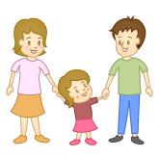It is really important to help your child to become independent with some activities at home. It will reduce their dependence on you, increase their confidence and help them to participate in school.

5 top tips!

* Get your child to put on their own **coat and hat** in the mornings.
* Get your child to put on their own **shoes**. Try to get Velcro shoes which will be easier for them to manage.
* Get your child to carry and open/close their own **schoolbag**. Get them to take out their books and put them back in after homework.
* Teach your child how to **wash their hands** by showing them how to use the soap, rub rub rub their hands together and dry them with a towel.
* Use a **reward chart** and some stickers to help!

|  |  |  |  |  |  |
| --- | --- | --- | --- | --- | --- |
|  | Mon | Tues | Wed | Thurs | Fri |
| Description: Description: Related image Wash hands |  |  |  |  |  |
| Description: Description: Image result for coat clip art Put on coat |  |  |  |  |  |
| Description: Description: Image result for shoes child velcro clip art Put on shoes |  |  |  |  |  |
| Description: Description: Related image Put books in bag |  |  |  |  |  |

**Compiled by Siobhan Mitchell, Senior Speech and Language Therapist, and Jillian Buckley, Occupational Therapist.**

**Fine Motor Skills**

These are activities using your hands. In school, your child does colouring, writing and cutting with scissors. It is important to practice these activities and do lots of games involving their hands to build up their strength. It is also important to keep their whole bodies fit and active so increase active play time outdoors, eg by going to the playground, going on bike/scooter, and reducing screen and tv time.

**Strengthen** those hands and finger grips:

* Playdough
* Building activities such as blocks and lego
* 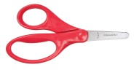Use clothes pegs - hang up pictures on a line or pick up cotton wool balls

**Scissors** activities:

* Get some small child sized scissors and show your child how to hold them
* Cut along thick lines on paper and cut playdough with scissors

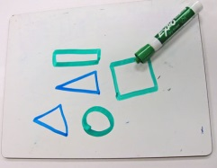**Pencil** activities:

* Drawing and colouring activities
* Drawing lines and shapes

[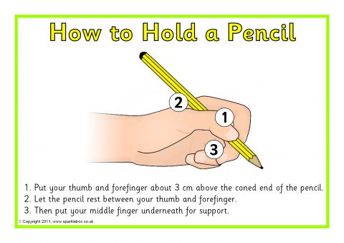](http://www.google.ie/url?sa=i&rct=j&q=&esrc=s&source=images&cd=&cad=rja&uact=8&ved=&url=http://www.sparklebox.co.uk/5941-5950/sb5947.html&psig=AOvVaw3THeHD87N7aiyMgaSALM_M&ust=1541765333536606)Top tip! Give your child very short crayons if they have difficulty holding their pencil correctly.

**5 Top Tips for Learning Language for Children in Junior and Senior Infants**

**1)** **Play listening games** – Playing listening games will help to build your child’s attention and encourages them to follow longer instructions. These skills are very important when understanding and learning in the classroom. Examples of listening games are ‘Simon Says’ & ‘Run and Touch’. 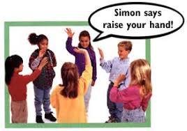

**2**) **REPEAT REPEAT REPEAT** – Six year old children should have a vocabulary of about 14,000 words! This means that children between 18 months and 6 years need to learn 8 new words a day!! They need to hear lots of types of words in order to put different sentences together. It is good to repeat new words for them lots of times and in lots of different sentences.

.

**3)** **Show them the right way** – It’s normal for young children to make mistakes in their speech. Say the word or sentences again correctly for your child rather than asking them to repeat themselves. For example, if they say “I goed to the park” you could say “wow, so you went to the park!”

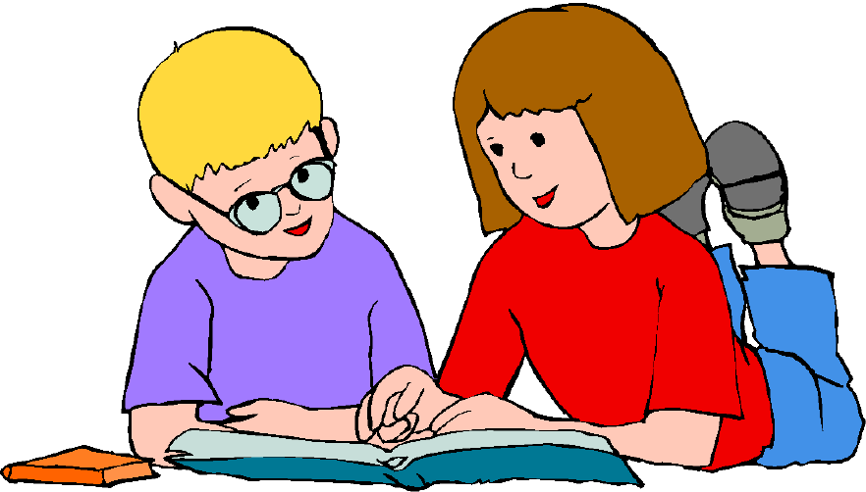

**4).** **Use every day routines to encourage conversation** - Language is learned during back and forth conversations in everyday activities. There’s a lot children can learn from talking about everyday events. For example, let your child help you unpack the groceries, put laundry in the washing machine or use a plastic knife to cut up fruit. Encourage conversation by talking about what you are doing and why.



**5).** **Encourage your child to tell stories** - Storytelling is an important skill because being able to describe things and tell events in order, as well as being able to re-tell stories, helps in later reading comprehension skills. You can help build this skill by sharing books or looking at photos together. Encourage your child to use the pictures/photos to talk about what they see and create a story. It takes lots of practice with both listening to and telling stories for children to become good storytellers.



**PLEASE COME ALONG TO OUR COFFEE MORNING IN SCHOOL ON WED 21ST NOVEMBER AT 12.30PM FOR MORE TIPS TO DEVELOP YOUR CHILD’S SKILLS!**