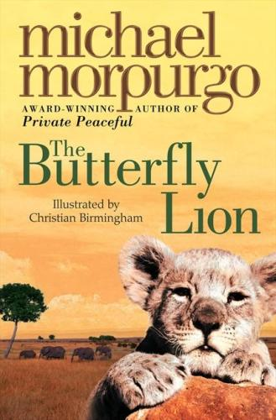
Book Review
Book: The Butterfly Lion
Author: Michael Morpurgo
Illustrator: Christian Birmingham
This story is yet another classic from the well known author Michael Morpurgo. The story begins with a boy who runs away from his boarding school and meets a mysterious old lady. The lady tells the boy of how she met Bertie and the adventures they had with the African white lion.
Young Bertie rescues a white lion cub from the African wild. They form a special friendship and become inseparable. Suddenly the unthinkable happens and Bertie is sent away to boarding school in England and the lion is sold to a circus. Bertie swears that he will never forget the lion and that one day they will see one another again. Bertie encounters many adventures as he searches for his best friend in order to fulfil his promise. Will Bertie find his lion in time or will the unthinkable happen as he breaks his promise?
This book will appeal to anyone who has a love for wildlife. It includes the themes of friendship, bravery, loyalty, war and loss. We would recommend this book for 8 year olds and upwards. The only flaw with this book was the unclear pencil drawing illustrations. Apart from this we found it to be a very interesting and a joy to read. We rewarded it with a well deserved 9/10

