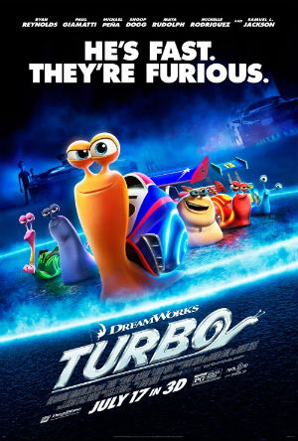
Film Review: Turbo
By Eibhlín Roebuck
Directed By: David Soren
Produced By: DreamWorks (Shrek, Madagascar and Kung Fu Panda were all
produced by DreamWorks)
Rating: PG
Voices of: Ryan Reynolds as Theo (A.K.A Turbo), Snoop Dog as
Smoove Move, Paul Giamatti as Chet, Samuel L. Jackson as Whiplash,
Michael Peña as Tito, Luis Gazmán as Angelo, Bill Hader as Guy
Gagné, Maya Rudolph as Burn, Ben Schwartz as Skidmark and Mike
Bell as White Shadow.
Plot:
Theo is a Garden snail who has had BIG dreams of having great speed and even racing in the Indy 500 one day - a dream his brother Chet, constantly tries to squash. Every day, they go to work in the vegetable garden. One day, after a day of embarrassing events Theo slides away in the night. By accident he falls on top of a racing car. He is sucked inside the engine when the car speeds up. He emerges changed and can suddenly zoom around at TURBO speed.
Theo and Chet are captured by Tito who runs a taco business with his brother, Angelo. Tito and his friends race snails for fun. They are shocked at the speed of Theo.
Theo meets other snails when racing in the snail race. They turn into his pit crew as soon as they see how fast he races. There is the leader Whiplash, Burn…who seems to like Chet, Smoove Move, Skidmark and White Shadow who believes he has stealth powers (but he really doesn’t).
Tito takes his brother’s life savings and borrows some of his friend’s money to enter Theo in the Indy 500. Tito, Tito’s friends and the snails head of to the race. Theo is instantly challenged by his hero Guy Gagné, a champion driver who turns out to be not the greatest hero after all……….
But will they let a snail enter the race? If they do will Theo be crushed?
If you want to know go and see “Turbo” in cinemas now!
The message in this movie is “No dream is too big and no dreamer is too small”.
“Turbo” is a great movie, with a good plot, excellent graphics and funny jokes.
I think it is more directed to the ages of 5-9 but it is still quite funny for older kids (and adults). I rate this film 9/10.

