Mr Toomey

Obelisk Park,
Carysfort Avenue,
Blackrock,
Co. Dublin

Tel: 01 2881771
Fax: 01 2834117

Principal: David O’Brien

Email: staugustines@sjog.ie
Web: www.saintaugustines.ie

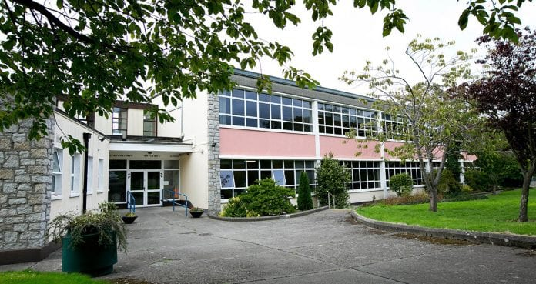

School for children with Mild General Learning Difficulties.
May accommodate students with a high moderate intellectual disability.
School does not cater for students with a diagnosis of autism and a moderate learning disability.

Mr Toomey
General Information:
- This school is for mild general learning disabilities.
- Approximately 160 students
- It is a co-educational school
- It caters for students from 8 – 18 years of age
- A maximum of sixty of our students have an additional diagnosis of Autism/MGLD.
- These MGLD may encompass a wide range of presentations and may be accompanied by additional diagnoses. Accordingly, best practise may require an integrated assessment of a student’s intellectual, social, emotional and adaptive living skills to determine the appropriateness of
an educational placement in St. Augustine’s School.
- In some cases, St. Augustine’s School may accommodate students with a high moderate intellectual disability and whose adaptive living skills are at a high level.
- Other considerations include a child’s individual strengths,
educational attainments, progress in school to-date, and their ability to avail of the programmes we currently offer.
- School Facilities
- Extensive modern computer suite
- Interactive whiteboard in all classrooms
- Resource Rooms
- Family Room
- Large gymnasium
- Ceramics workshop
- Library
- Swimming Pool
- Outdoor facility for basketball, soccer and tennis
Mr Toomey

- Junior Certificate standard Home Economics kitchen with 6 work-stations.
- The Support Team at Saint Augustine’s currently consists of professional staff in the areas of Social Work, Speech & Language Therapy, Psychology and Pastoral Care.
- Opportunities are also available, throughout the year for students to visit community facilities and take part in leisure pursuits e.g. hill walking, pitch n’ putt, visiting museums, libraries, places of historical and cultural interest, as well as more everyday activities such as shopping and visiting restaurants.
- Festina Lente Mobile Equine Outreach Programme
Many of our students have been participating in this programme over 2016-2017 & 2017-2018. Students get the opportunity to care for the horses on campus. This outreach programme serves to support students’ social and emotional well being while learning how to care for the horses.

Mr Toomey
Curriculum:

Students aged 8-14 years (classes: Primary 5-6 and Post Primary
1-6)

These students follow a broad primary curriculum including

Reading
Writing
Religion
Geography
History
Science
Home Economics
Art
Ceramics
Music/Drama
Nature
Sports
Social Skills/Personal Development

We are currently introducing Junior Cycle level 2 for students in the age range of 13 years.

Mr Toomey

Students aged 15-16 years (Pre-Vocational Development 1, 2 and 3).
These students avail of the above programmes, and additionally those listed below.
- Further Education and Training Awards Council
- (F.E.T.A.C. Level 3 – General Learning) Communications, Mathematics, Ceramics, Food and Cookery/Food and Nutrition and Living in a Diverse Society
- Junior Certificate School Programme:
English, Mathematics, Irish Culture and Civic, Social and Political Education

Work Experience.
(Internal and External Placements)

Students aged 17-18 years (Vocational Development 1 and 2). These students avail of the above programmes, and additionally those listed below.

Further Education and Training Awards Council
(F.E.T.A.C. Level 3 – General Learning) Choice of 22 modules including Office Procedure, Music, Drama, Horticulture, Health Related Fitness, Work Orientation etc

Junior Certificate Examination
(English, Art, Home Economics at ordinary level)

Junior Cycle level 2 (English and Short Courses)
Mr Toomey

Life Skills & Independent Living
Career Information Graduation Preparation

Generic Work Training Specialisation in Training
(1st year) (2nd Year)

Generic Work Training
(1st Year)

Specialisation in Training
(2nd Year)

Mr Toomey

Referral Procedure

Applications are processed during the academic year prior to enrolment and will be evaluated on the basis of the selection criteria outlined below.
As a student’s needs may change over time, applicants are not placed on a waiting list for enrolment in future years.
The enrolment process starts again each new school year.
Application packs are available to parents/guardians in the school year prior to making an application.
Applications for enrolment of students for September 2020 will only be accepted by registered post from Tuesday October 1st, 2019 onwards. All applications, including hand-delivered applications or registered or regular post received before 1st October, 2019, will be returned to sender.
Envelopes containing applications received by registered post will be selected at random each day and assigned a number on category list.
Incomplete applications will be returned.
As we are oversubscribed for placements each year, applications will be divided into three groups as per Psychological Report and processed in order from list 1-3 below:
1) Mild General Learning Disability (MGLD) and Autistic Spectrum Disorder – all applications from students in this group will be processed up to our cap of 60 students within the school.
2) MGLD – IQ 50 – 70 and Moderate Learning Disability with High Adaptive Functional Living Skills.

Mr Toomey

3) Oversubscribed years – applications from these students with dates of birth between 01/07/02- 30/06/03 and 01/07/04-30/06/05 will only be processed after other applications outside of these age brackets.
Parents and professionals wishing to enrol a student in St. Augustine’s School should forward a letter of referral accompanied by the completed documentation requested in the
application packs i.e.

Pack 1 – Parents/Carers
NCSE forms (see Appendix B)
o Form 1 – SNA Support
o Form 2 – School Transport
o Form 3 – Assistive Technology
o Form 7 – Enrolment in a Special School
o Behavioural Care Needs Form (BCN 1)
Registration Form (to include copy of birth certificate and up-to-date medical information)
Medical Protocol Form (if already in place)
Psychological Report
o Should have been conducted within 2 years of the date of application
o Should be conducted by a qualified psychologist
o Should state diagnosis
o The same report should recommend a place in a special school
o The Psychological report should state if child will need the support of a SNA in a special school

Mr Toomey

o Identify the special educational needs of the pupil along with a statement of resources and interventions required to meet such needs.
o It is preferable that the students IQ be identified in the report.
Child and Family History Form
Permission to seek and share same information with relevant agencies supporting
child’s best interests such as the HSE, SJOG etc
Parent / Carer Referral Form
Assessment of Independent Living Skills

Any other relevant reports e.g. occupational therapy, social work, speech and language, etc. These reports will assist when applying for assistive technology and other supports

Pack 2 – Current School
- School Referral
- Recent individual education plans
- Recent School report (including resource if relevant)
- Samples of student’s work (3-4 pages each of Maths and English – no workbooks copy books, etc. please).
- The referral letter should be addressed to: The Principal, St. Augustine’s School, Obelisk Park, Carysfort Avenue, Blackrock, Co. Dublin.

Mr Toomey

Applications will be acknowledged by the School Principal within 21 days. This acknowledgement does not infer an offer of a place in the school.
A copy of the school’s Enrolment Policy is sent to all applicants upon request.
Our Enrolment Policy is also available on our school website www.saintaugustines.ie.
St. Augustine’s School does not cater for students with a diagnosis of autism and a moderate learning disability.
Unsuitable referrals e.g. students with a diagnosis of severe-profound will not be processed and the sender will receive a phone call from the school principal.

Criteria for Acceptance
All applications will be evaluated using the following criteria:
- The applicant meets the profile of the school.
- Appropriate documentation is supplied to enable the school to make a decision.
- There is an age appropriate place in the school. St. Augustine’s is oversubscribed for students born between:
01/07/2002 and 30/06/2003
01/07/2004 and 30/06/2005
- All applications received from students in these age brackets will only be processed after other applications outside of these age brackets.
- The applicant’s medical needs can be safely managed by staff.
- The capacity of the programmes at St. Augustine’s to assist the student applicant in meeting their potential.
Mr Toomey

- The capacity of the programmes on offer, to meet the parents’ expectations regarding educational and other outcomes for their child.
- The needs of the whole school population at the time of application.
- The health and safety requirements of the applicant and/or other students are not compromised.
- The health and safety requirements of our staff.
- Distance from school and sanction from the National Council for Special Education (NCSE) for bus transport.
- The capacity of the school to provide for the needs of the applicant considering the necessary resources available to it.
- Parents/guardians of successful applicants are willing to engage with the school by signing relevant School Policies - Code of Behaviour, Health and Safety, etc.
- A student with significant emotional/behavioural challenges may not be offered a placement if it is believed that his/her enrolment would impact negatively on the
safety, welfare or learning of other students.

Mr Toomey
Programmes
Academic Programmes currently on offer:
- Primary Curriculum
- Junior Cycle level 3
- Junior Cycle Level 2
- Quality & Qualifications Ireland (QQI) Level 3 (previously known as FETAC)
- Junior Certificate Schools Programme (JCSP)
- Home Economics
- Art, Ceramics
- Music
- Sport e.g. PE, swimming, athletics, basketball, football, cross country
- Religion, including preparation for the Sacraments
- St. Augustine’s School is classified as a primary school and so we adhere to the annual calendar for primary schools.
- Our more senior post primary students aged 16-18 spend a half day in school and a half day in the Vocational skills areas.
- July Education Programme (also known as July Provision)
Students with a diagnosis of autism may have the opportunity for an extended school year to include up to four weeks in July.

Vocational Skills Programme (students aged 16-18)
While in Vocational Skills, students may avail of the following programmes on site:
- Horticulture & Environment
- Technology
- Catering Skills
- Work Experience
- Person centred planning/Career development
- QQI
- Sport

Extended Day Programme
Some students get the opportunity to improve their independent living skills and social skills in our Extended Day Programme (between 3.00 and 9.00 p.m. – Monday – Thursday).

Receptio

Main Entrance

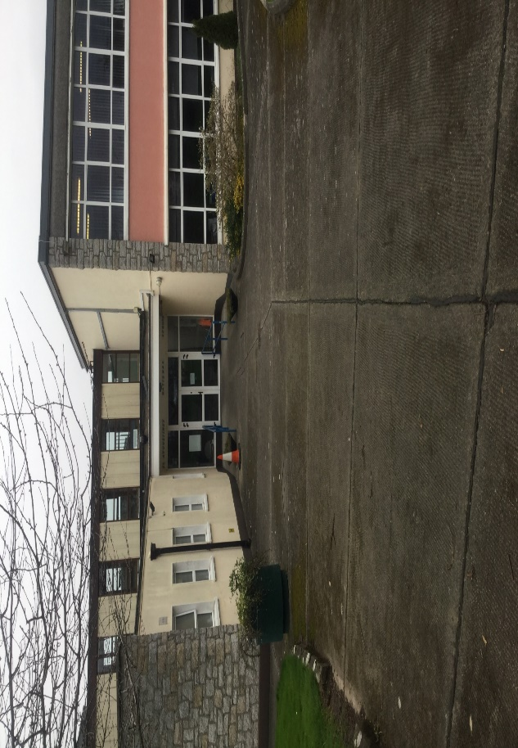

All weather pitch

The all-weather pitch is a place where students play sport, such as football, basketball and cross country outside and also it can
be used for PE. The school uses it when the weather is good and some students use it in the mornings instead of the hall.

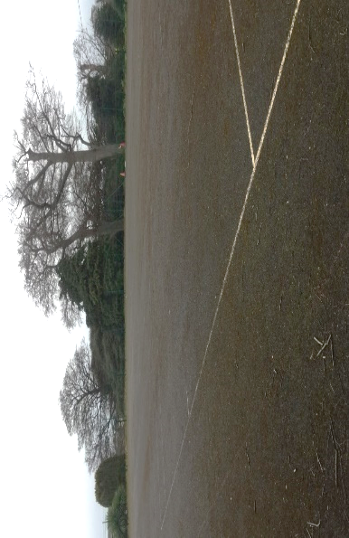

The Big Canteen

The big canteen is the place where the Vocational students (16-18 years old) and Vocational staff go for their lunch and break. You can buy lunch from the kitchen where the catering staff and students work. You can also make tea and coffee to drink as well.

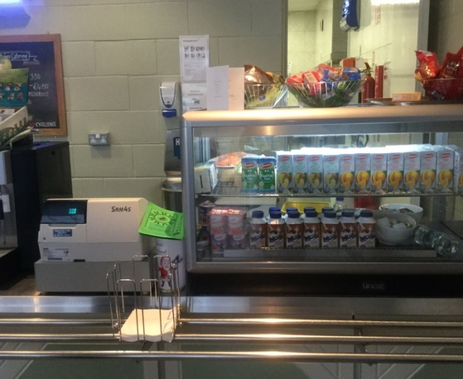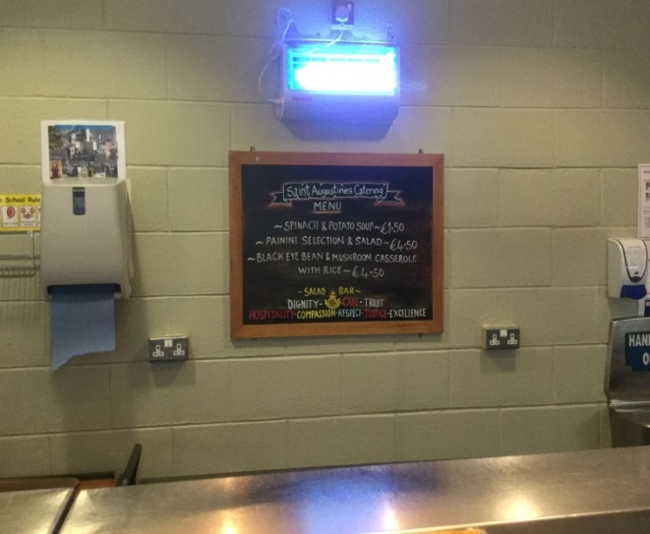
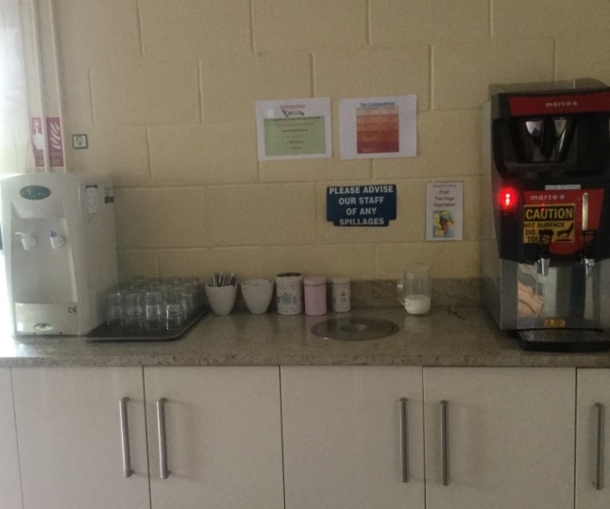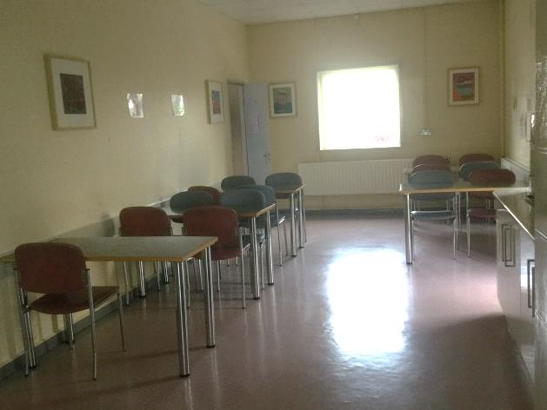

Horticultural Area

Horticulture is the place where you can learn about nature and recycling and how to grow and look after plants. Mr. Laheen is the
instructor in horticulture.

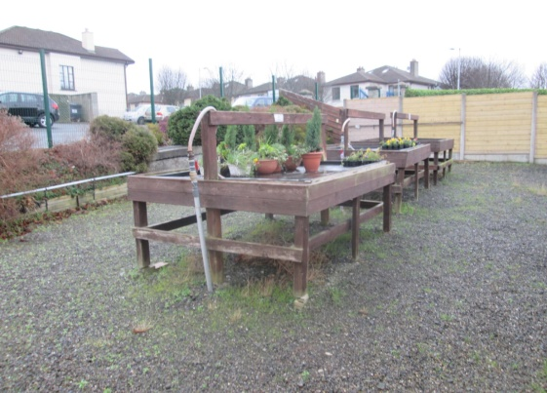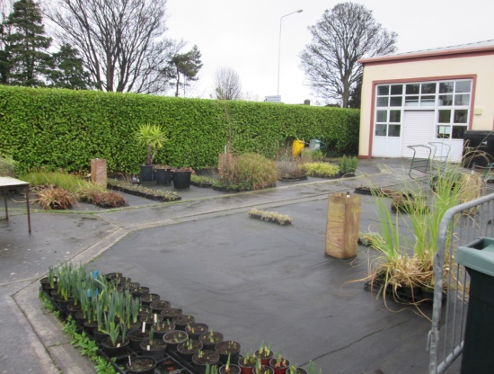
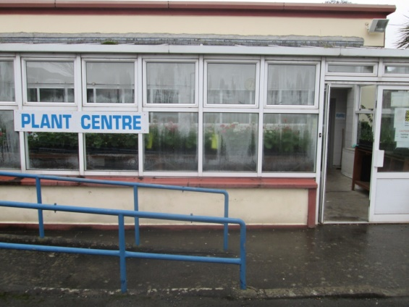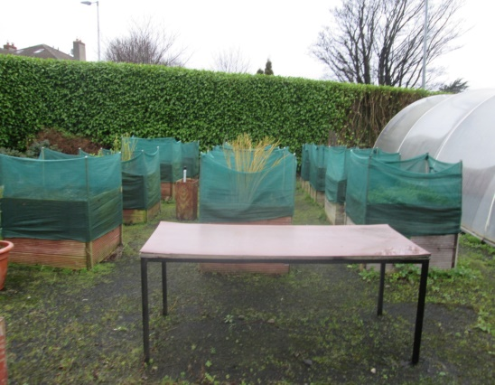
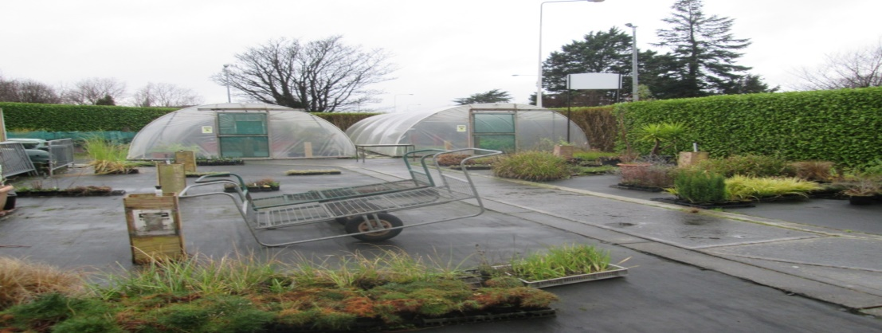

The Library

The library is used by many students as a place to read books. Some classes go there once a week with their class to read books.
The reading partners program can happen in our library and sometimes students go there to play chess.

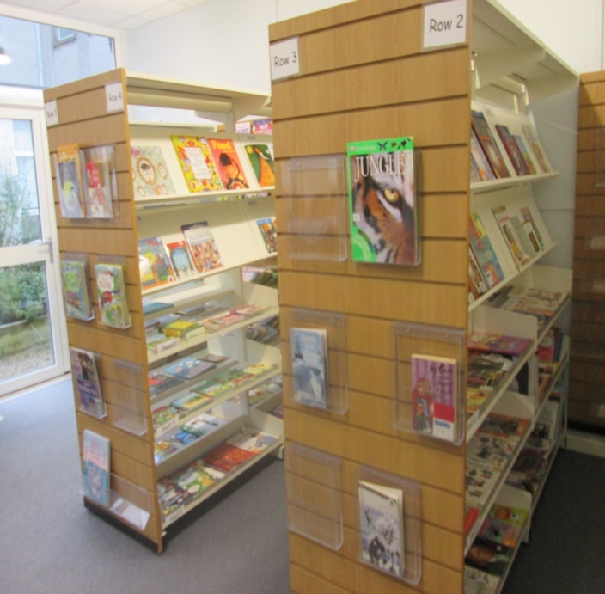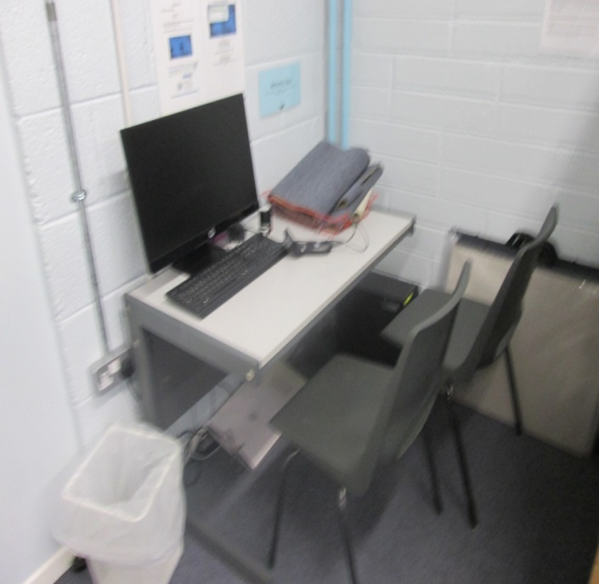

The Playground

The playground is used by students in our school to play. They play in the mornings and sometimes before going home. It is a great place for many students in St. Augustine’s.
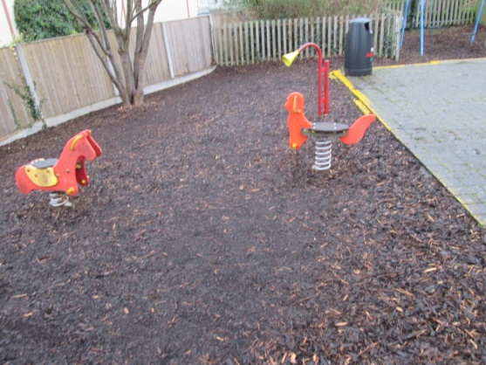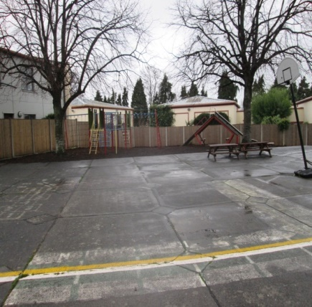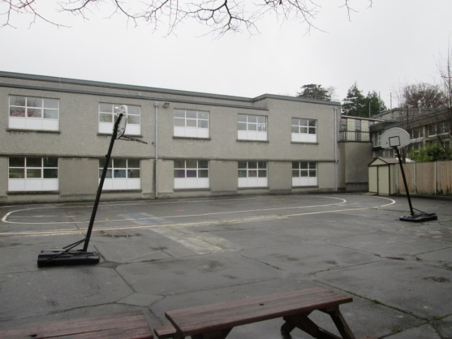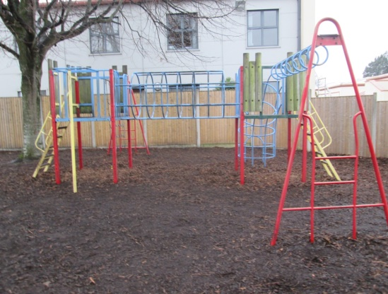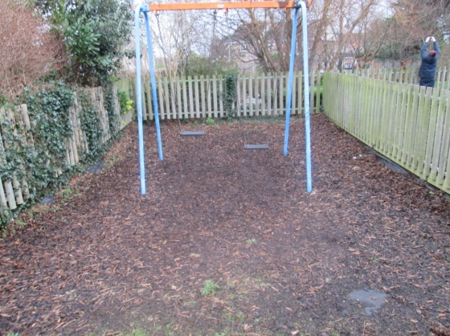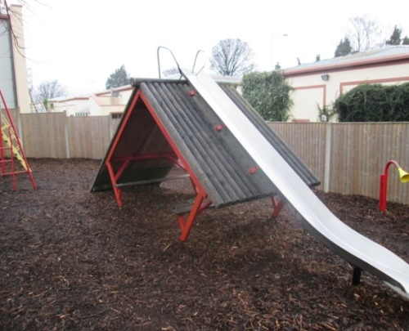
The Computer Room

The Computer Room is a place where you do work with the teacher Mr. Hurley.
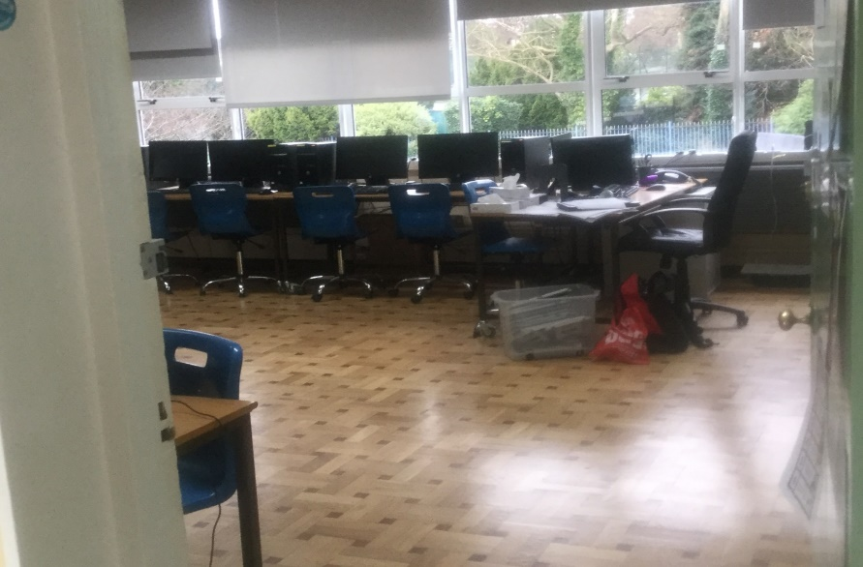
The Family Room

The family room is a nice quiet place where some students go into the room and relax and usually talk to a teacher or their friends about something on their minds.

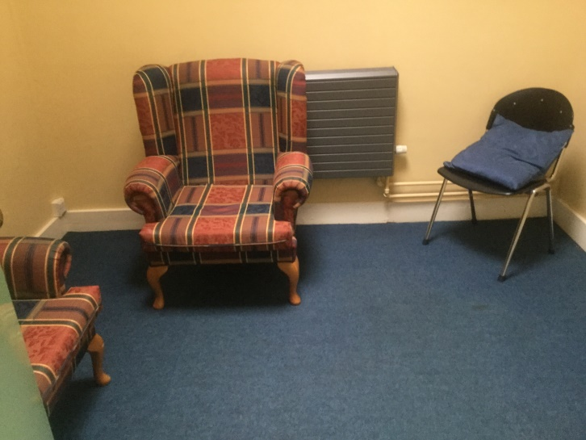

The Work Experience Room

The work experience room is a place down near our Vocational area where students, parents and staff meet to discuss work experience and learn new skills.

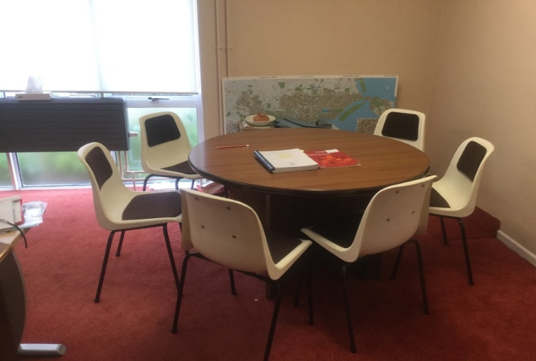

Secretary’s Office
This is where the school secretary Anne works and does all the paper-work for the school.
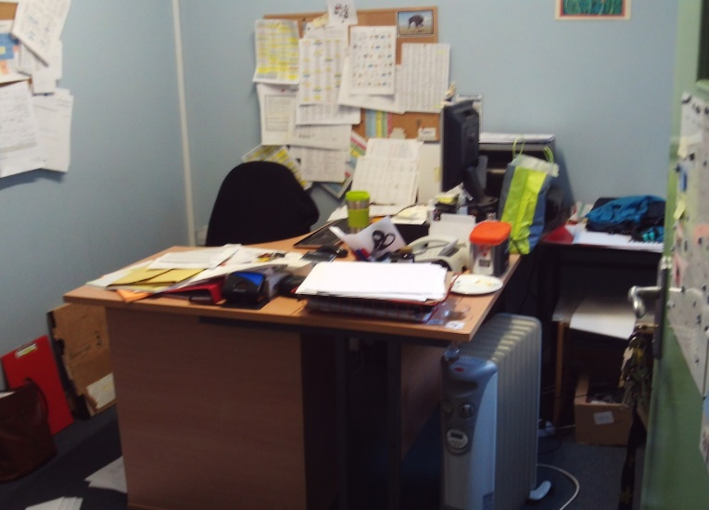

The Courtyard
In the courtyard students go outside to relax and sometimes in the summer have BBQ’s.
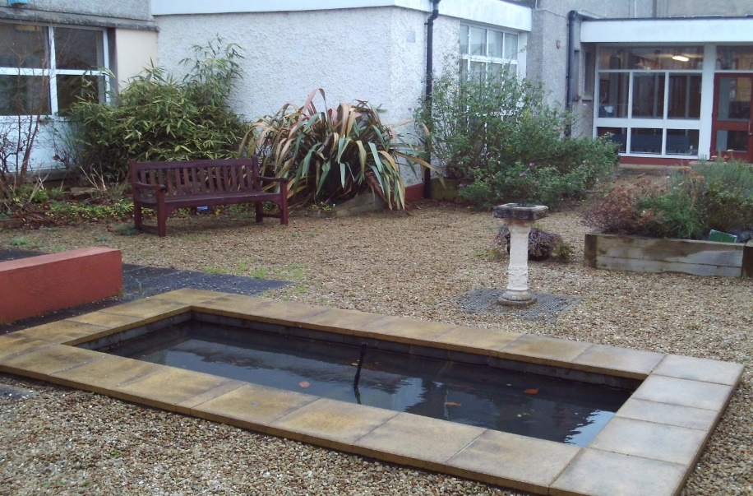

The Den
In the Den younger students from the bottom corridor go there to play with Lego, toys and dolls.
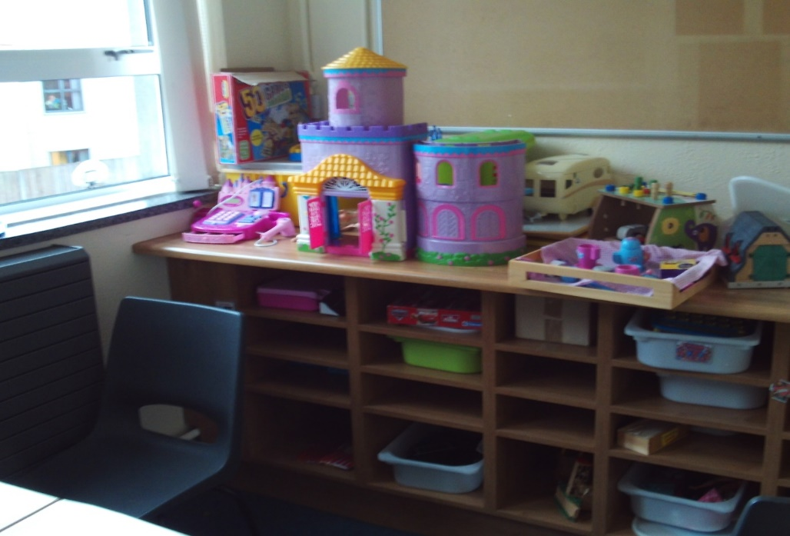

Small Canteen
This is a small kitchen where younger students go to eat.

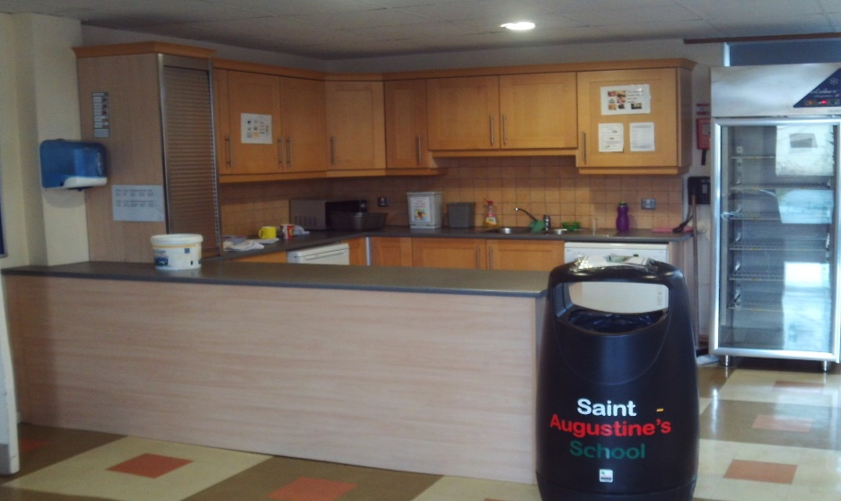
School Hall
The school hall is where we have assembly on Friday mornings. We also have Christmas concerts, staff meetings and some students have lunch here too.
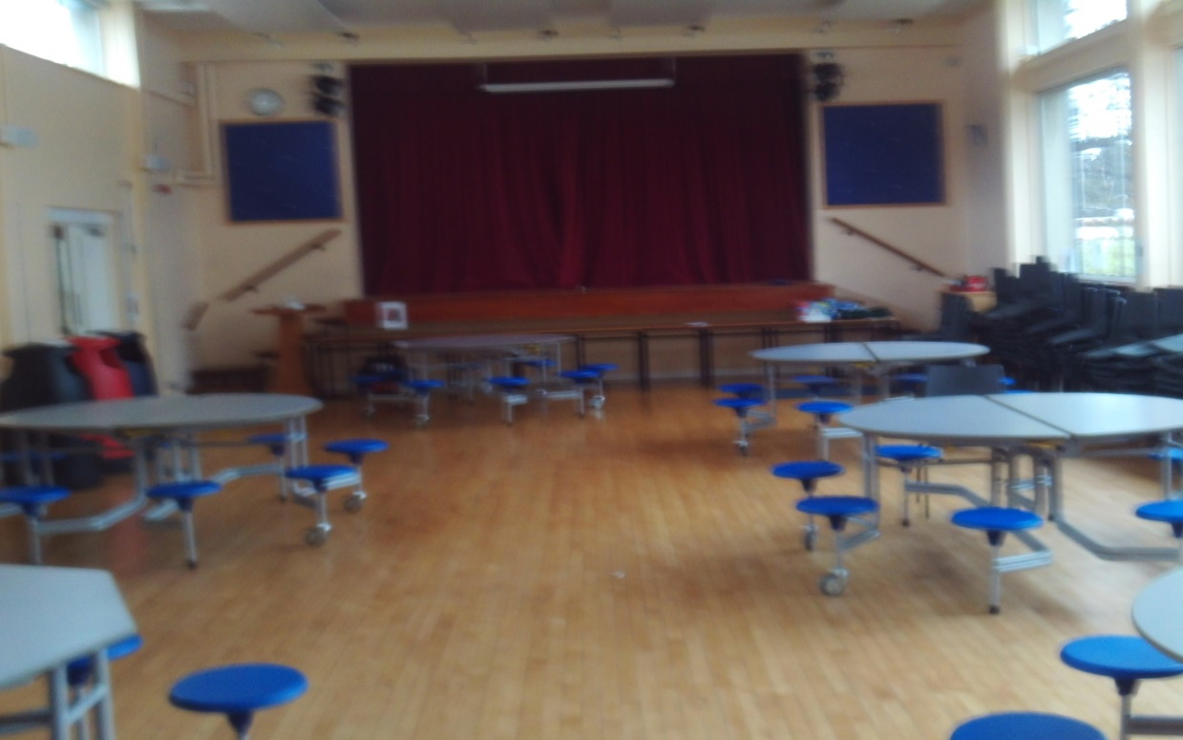

The Principal
The principal runs the school and sorts out meetings for parents, teachers, snas and helps students.
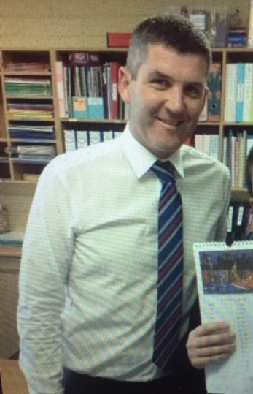
The Games Room
1st and 2nd year vocational students go there to meet before work. The students have lockers there. They can relax and play games.
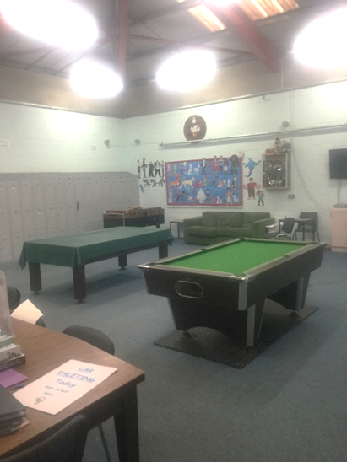
The Exercise Room
Exercise room is for people to work out and get fit. Sometimes students can go there to relax. Younger students use this room.
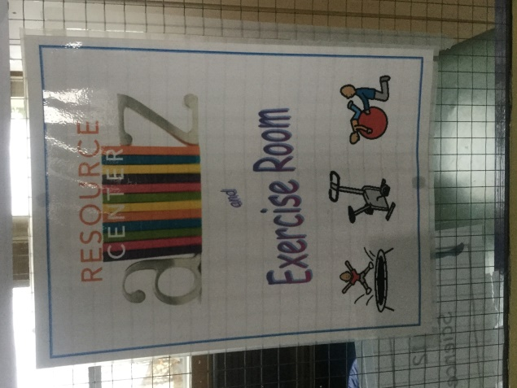

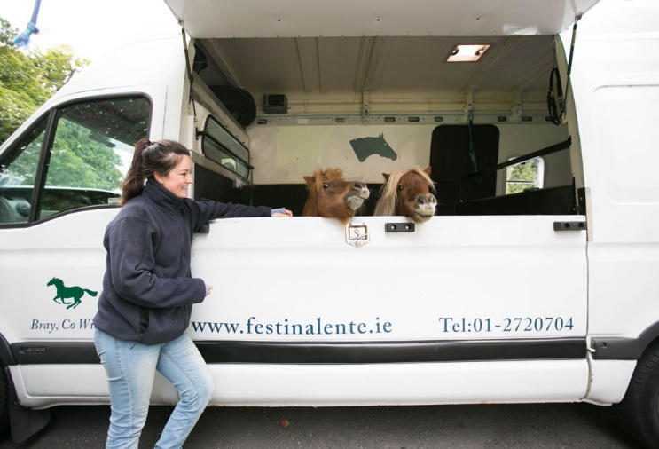
Festina Lente Mobile Equine Outreach Programme
Many of our students have been participating in this programme since 2016. Students get the opportunity to care for the horses on campus. This outreach programme serves to support students’ social and emotional well-being while learning how to care for the horses.

Gym Art Room Swimming Pool
