  - Quentin Blake
- Quintin blake is a famous illustrator and author.
- He has illustrated his own books as well as other authors , including Roald Dahl.
- he lives in london and aLSO LIKES TO SPEND TIME IN FRANCE.
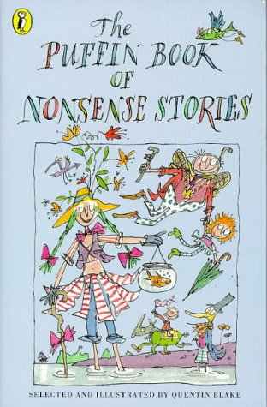
- HE ILLUSTRATED BOOKS LIKE THE TWITS,GEORGES MARVELLOUS MEDICINE AND PUFFIN BOOK OF NONSENSE STORIES.

