- It’s summer and four friends go to visit an island for the day. The four friends are late for dinner, so we need to help them get back quickly! The four friends must all get back to the mainland on one little rowing boat. They’re all on the island at the end of the day. The rowing boat carries two people maximum at any time. It is quite dark in the evening and they have just one lamp. When they are travelling, they must carry a lamp to see the way. A pair must row together at the rate of the slower friend as they are sharing the lamp.

- Belle takes 1 minute to row across
- Hugo takes 2 minutes to row across
- Zara takes 7 minutes to row across
- George takes 10 minutes to row across

- Can you join the dots with just four straight lines and without lifting your pencil?
Draw nine dots a page. Can you join them with just four straight lines?

Hint: to solve this you have to think a little ‘outside the box’!

Answers on the next page!
The fastest solution takes 17 minutes for all of the friends to get back to the mainland. The second fastest solution takes 21 minutes for all of the friends to get back to the mainland.

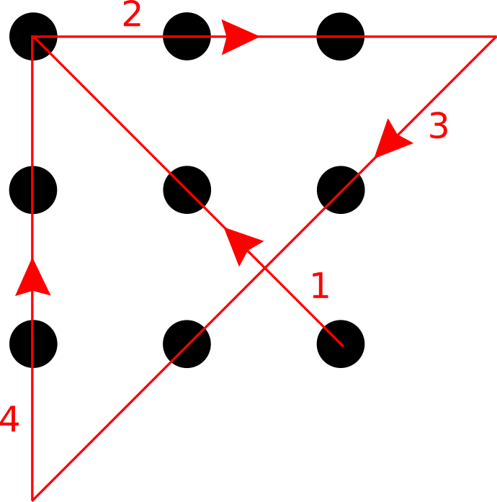
- Start from the bottom right dot, draw a line through the central dot ending on the top left.
- Connect the top row, but don’t stop on the top right – continue on to the next dot if the pattern continued.
- Now draw a line through the middle right and middle bottom – continuing again to where the next dot would be.
- Finally connect the remaining 2 dots in an upward line.

