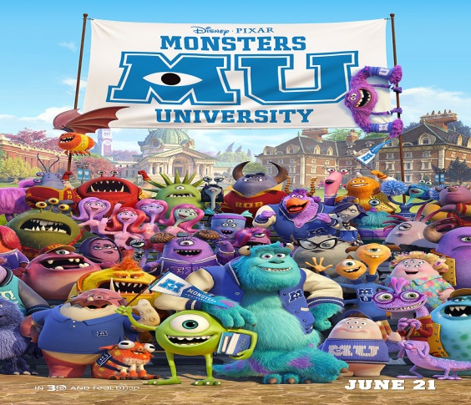
Name of Film : Monsters University
Film Type: Animated Childrens’ Film
Reviewed by: Sophie Kelly

When Mike Wasowski, was 6 years old, he went on a trip to Monsters Inc. with his class. Mike Wasowski was the most unpopular and smallest monster in his school, Frighton Elementary. Nobody wanted to be his partner for the trip so Mike had to partner up with his teacher.
Inside Monsters Inc., Mike realised he wanted to work there as a Scarer, after seeing a professional Scarer demonstration.
The years passed and Mike followed his dream to become a Scarer. He attended Monsters University as it was famous for its Scaring Programme. No one believed that Mike had the potential to become a Scarer and Mike wanted to prove them wrong. This is where he met his new best friend Sully.
Meanwhile, Mike had picked up a leaflet about the Scare Games which is basically a monster version of The Olympic Games. So, Mike gathered a team, which included Sully and he aimed to win the Scare Games because he wanted to prove he belonged in the Scaring Programme.
Will Mike, Sully and the team win the games?
Watch the film to find out!!!
I rate this film 3 out of 5 stars as it was a bit too childish/babyish for me but, I would recommend it for younger children around the ages of 6-8

