Really Big Wordsearch!

Can you find all of the synonyms for ‘big’ in the wordsearch below?

S E C Q O X L M T O Z H C G Z N E E V I S S A M V A H N G Q D F Y T G L P U S X
Z M B R J P F Y S K K R P P R U A K G F R C O M K L F Q W T K Y N Z I O V B F P
R Q H H D W C U J P C K U U O H P B N B N U F W Q X O S R R D J A B L H O L D T
V A Q Y M U P M Z H H A Q U S H O Z R H D Q M R T W R M M L Y D L E M Q Y Y M X
K S X B V M J E R Z C H I U M F X N B K R F J Q S L E Z Q Y V R X J A X Y F T A
U F N X Y S S P I N L C W Y K T T A B J O B D A B G J X V Z K L O V Y U B G H F
G E C J S P F D B H M V Q W I U S T I B E W C U E S C T Q J L D K W A J Y O A L
V C I H H U P F U N E V J U N L Q Z B N M E X P A N S I V E K I O H J C J I Q R
R L L G J R O G B N K B J K N U Q Q S M P T V B N H E O G Z D K T U M L H V L L
X L O Q J G E N H B H M E F Y R K G V D T E C K D V N K E B P O L D Z T N K C V
E Y C E N J T T I J X U Q Z U H Y T P Z W H D Y I X O L S F M B B H S S C K T A
Q V U E N J W F S M B H Q W Q P W R A N J X N P O F R B Q M K W T C U Y U L S F
A N J C M C A D N X U B R G D J B H M A E Z O S B Y M C A G D S X B R M Y Q H K
O E X F H V K K G F W L I Y B J J J A P E W E T J Q O M D E G R S V X B S Z F G
D G R M F P B R Q E M B O P Z C I T Z C R Z Q D V S U G H P Z T T X Q N L C K M
G H M P Y G Z B X A Z T S V F K M O A Q Y C Z H Q F S C P Y A T N K M M O E X I
T L P B N N R R Z O I N U U E N F D D X K W K C J Y P H I N K F Q D S N L Y C G
U J M G P W M E I Q E N O O Y G O V L J R F X H H I Z B T F G S R E B C F W Q Z
N A U T N A G R A G C O D K G W E U H G Z B O T Z A D I V K W H J B M J W S I P
E D G Y D H Q O I T Y I N T D Q A Q B P J D Z P H S A A O I G Z R O Y W G E E B
G X X A J W R G S D W T E F T E U J V P V T M L B L V M D A A A I D O B W F U K
V I T Q K I U N Z D X B M I S Q I D P F H S T E H Z K P L E P B A D X U H J K R
K P C E T D Y Q S S C A E M Z R H P Y A U Y N U J V H L J Z F Y E L H O G S D J
G U R J N O Q E B F F L R S O S E G Y U T S T W D D E E U Z U X S C B L M X Q F
F C C X W S W S M E F I T V Q M U D E D H E M B I G D O M Y R F X L X Q U Y P K
Y F M P C X I G F Y K X D U L P B E T A C C G R C J W M V E X M V I T S A V Z U
P B W E T B V V T Q W K F Y V A D S Z T M K R I Z H F N B G W F J M W F T M S L
T Q W K F Q D W E B P D V Q P E U T Y R A Y I W P H L J X G G H K Z L M M X H N
H H E O H A J G L A R G E D B O O J G H B M N Y A A T B P U H C S Y P I X Y X N
D C I Z W W I C P Q Z Z N L G H F P W E L P B D Y F H Q E O J D O Y T L M V O I
O V X E E G M U K F Q S L N A T Z L X R Z G G M Z F T Z V U A S G U C D F Q X C
K A Z N A K M N K P X Q O X O L X A Y J A A C S Z P I N F Y H Z F H P G D P S Y
Z M E N E R T J V V C M C P T X N J X K J A Q M Q Y W C Z O G D H K N J W A X T
K O T L D X P G M X U U K A H X P G J Q X Y P A Q G O A E G V U N L S E M M Y J
L I C Q B I A R T H C K O L I A Y T J C I X F B O G H R S I O Y M Z M N M R N M
C Z P Y Q A S F E B K X G Q T F P I U D Z V K F G V I T N R L E R A K H G Q X G
M U C E O I Z K O L Q V K X L G P F W B Y F B I Z U M Z E R F B T Y P M F P Y J
Z S D O D G Q I V I T F H P D T V Q I H W E J K O O U K M U J I J P B Y M M C Z
E C I K W J U P S T T U G Y Z C R W S L E A S J T Q F E M A B H D P Z Y G H C B
R A C R A Q T S K E E Q F H R S N A N D M R E T J B L X I B W N J Z O M T Z B S
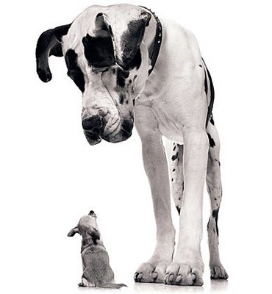

AMPLE
ENORMOUS
EXPANSIVE
EXTENSIVE
GARGANTUAN
GIGANTIC
GREAT
HUGE
HUMONGOUS
IMMENSE
LARGE
MAMMOTH
MASSIVE
SIZABLE
SUBSTANTIAL
TREMENDOUS
VAST
VOLUMINOUS

Really Small Wordsearch!

Can you find all of the synonyms for ‘small’ in the wordsearch below?

V T E V U F D E D D
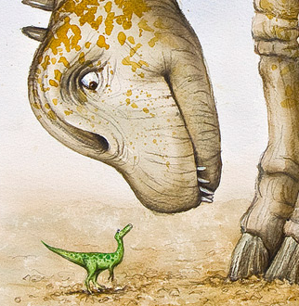
C X L U C D H M I E
Q T U Y G N Z M W Z
Y U C A G V I S Y I
P N S W T N S Y D S
F M I N U T E W X R
Y V N T X N H R A E
L D I P J K K N Q D
U V M B J P M M B N
E R U T A I N I M U

DIMINUTIVE
MINIATURE
MINISCULE
MINUTE
TINY
UNDERSIZED

Can you think of 3 more synonyms for ‘small’?
1.
2.
3.

Contractions Wordsearch

Work out what these contractions are short for, then search for the expanded forms.

Isn’t Let’s She’ll Shouldn’t

They’re They’ve Weren’t Won’t

You’re You’ll Could’ve Wouldn’t

H Y T O T F E L E Q S T Q B E
C A O O K O G B H P D P O J R
Y Q V C N E N E R A Y E H T A
S E K E Q E V D N Y O E Z Q U
V R V L N A R S L O R K W U O
K D F O H O U E D U A O O I Y
E A M Y R T T G W W O A I S X
J G E Z E O G O E I Z H H X X
U H S L Q N K F N L A E S A E
T M Q R E D H N T L W C A X Z
E V A H D L U O C I I U L E S
D F N Y Z U W I L L N O T K A
I S N O T O H L O B G L W Z E
R E E O F W X D E W S X S X R
V R H C Y L Z E L Y P D N G I

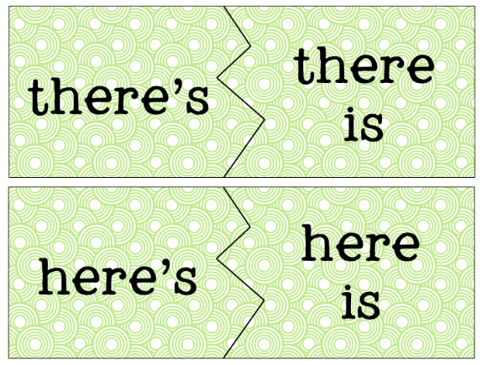
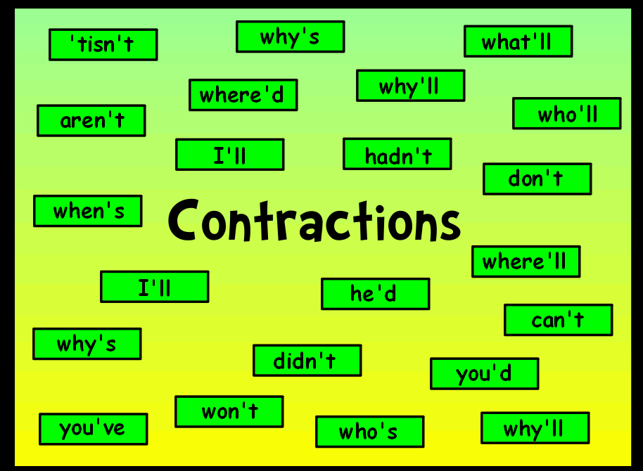

Hink Pinks!

Hink Pinks are rhyming answers to silly clues.
(e.g. tight carpet = snug rug, empty seat = bare chair).

How many can you solve?

- Meat Stealer = Beef thief

- Heavy Rodent = Fat rat

- Raining Tulips = Flower Shower

- Complimentary Oak = Free Tree

- Amusing Rabbit = Funny Bunny

- Drums Talking = Percussion Discussion
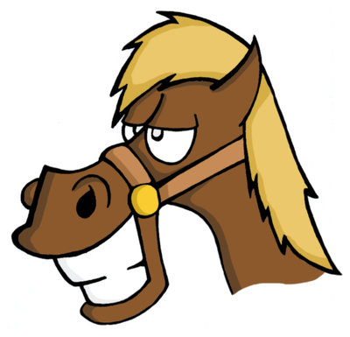
- Fake Horse = Phony Pony

- Sugary Paws = Sweet Feet

- Simple locomotive = Plain Train
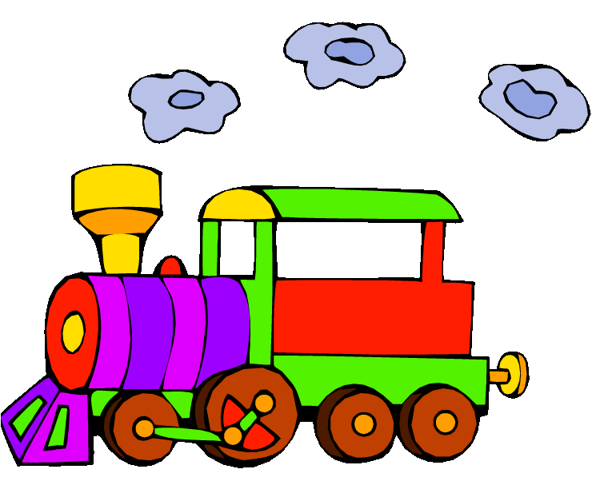

Can you think of your own hink pink?

Clue_______________________ Answer______________________

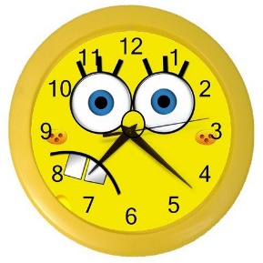
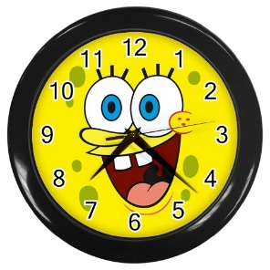
Time to think!

Write each of the following times as AM and PM on a 24 hour clock.

1. 02:50 / 14:50 | 2. 03:49 / 15:49 | 3. 09:23 / 21:23
4. 02:17 / 14:17 | 5. 00:55 / 12:55 | 6. 07:04 / 19:04
7. 04:53 / 16:53 | 8. 08:27 / 20:27 | 9. 06:21 / 18:21

Rebus Riddles!

Use your lateral thinking skills to work out what phrases these images stand for. Write your answers on the line.
THINK

Remember, Think outside the box!

A walk in the park

Crossbow

Banana Split

Domino

Downpour______

6.Read between the lines
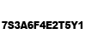

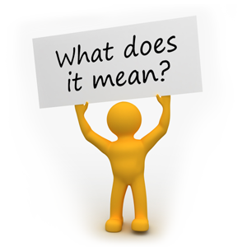
7.There’s safety in numbers

8. Make up

Colour By Maths!
Solve the calculations and fill in with the correct colour to reveal a summer picture.

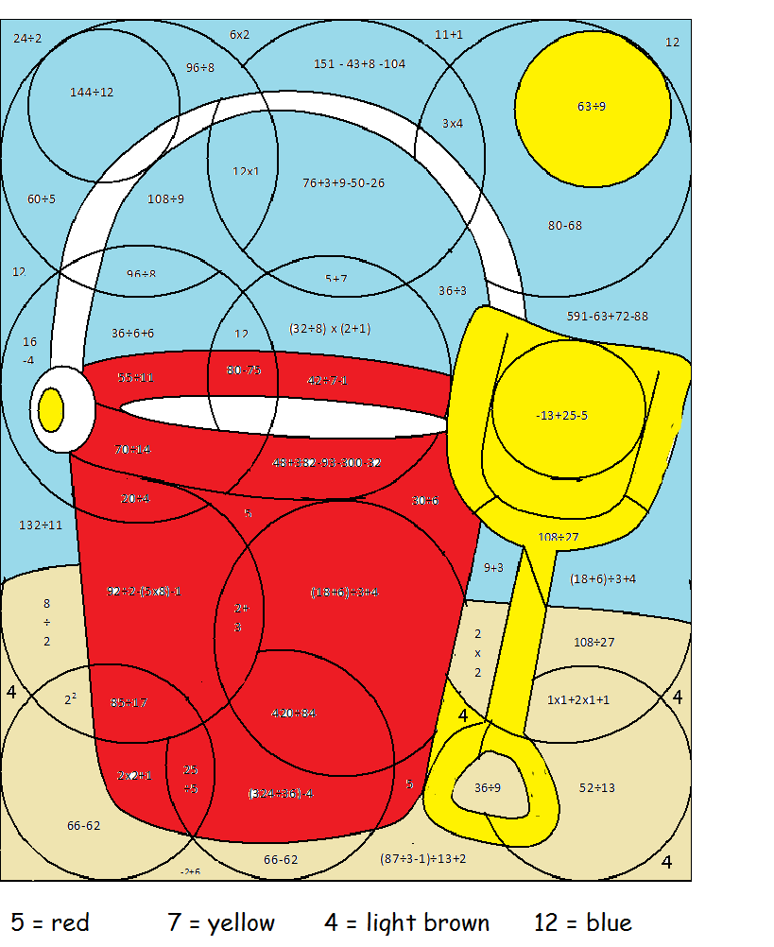

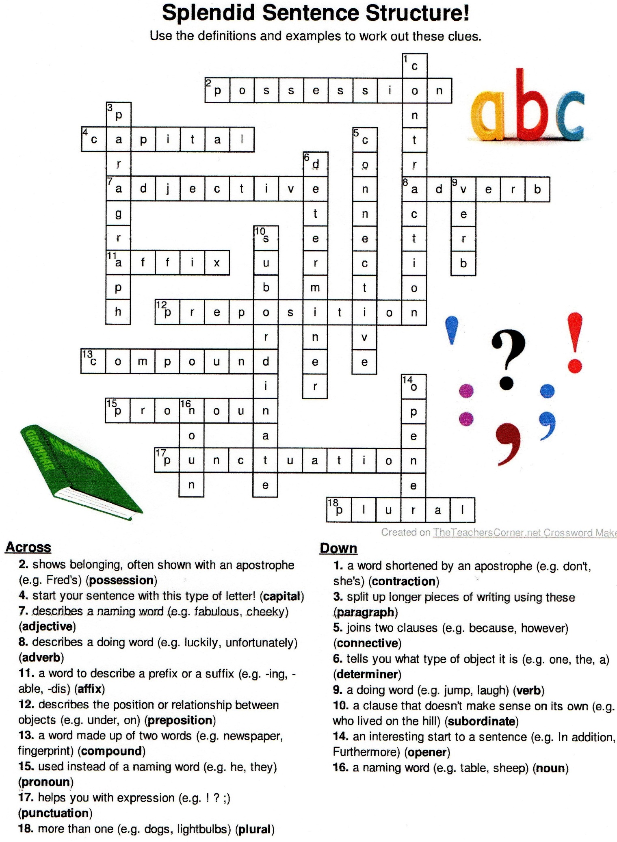

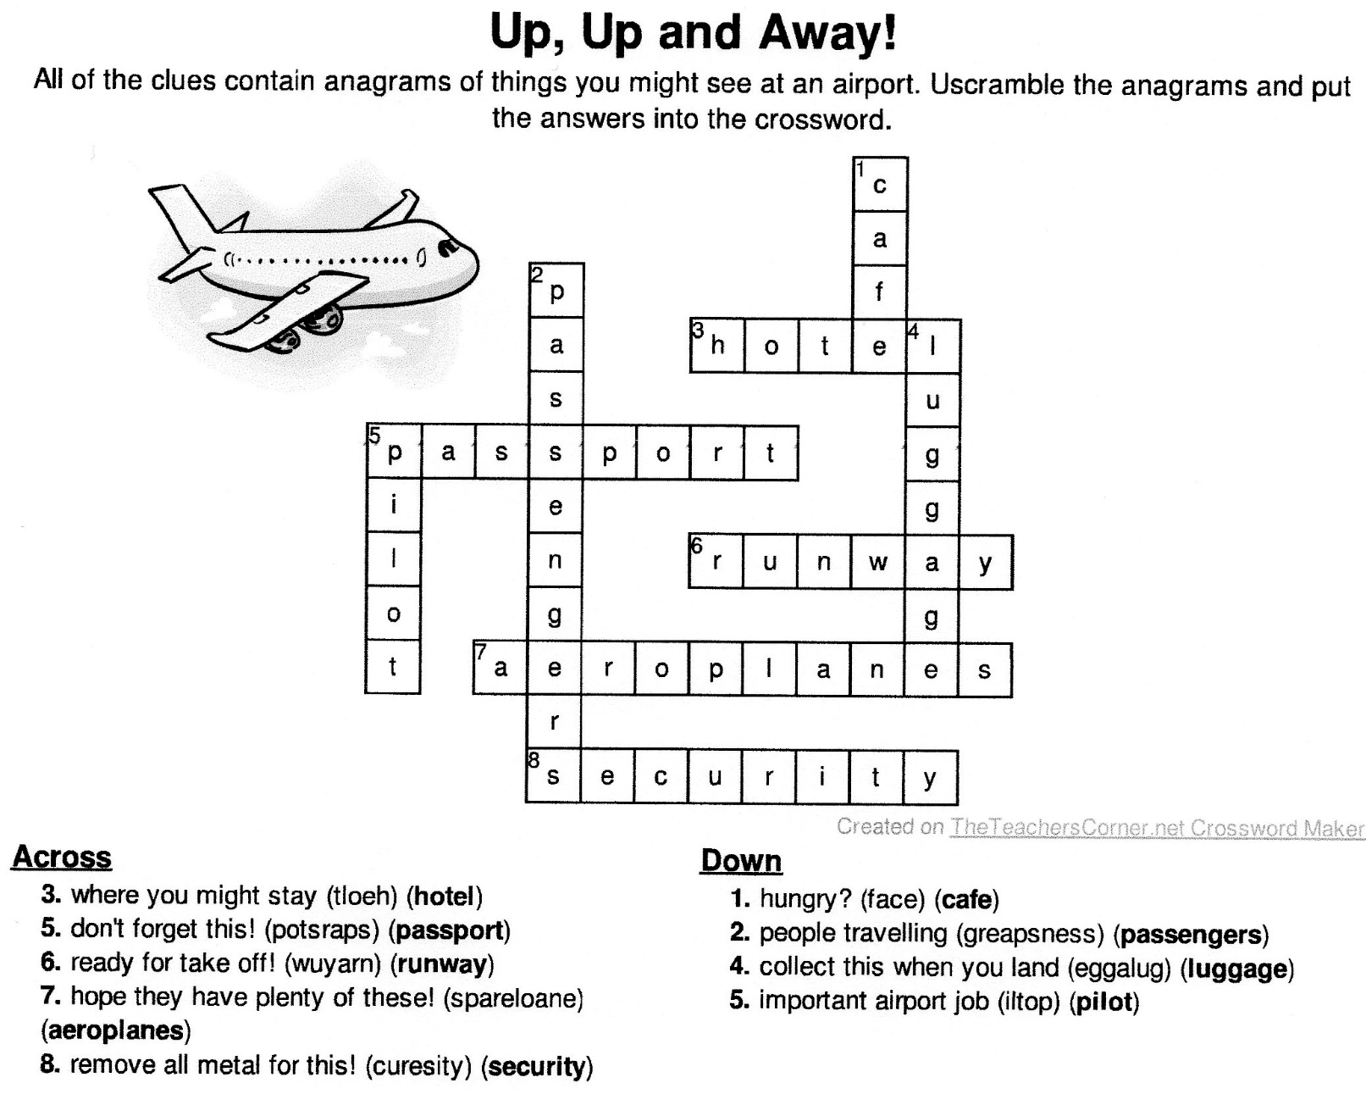

Maths Maze!

