Facts about Quentin Blake He lives in a flat.
He was a teacher.
He is a illustrator.
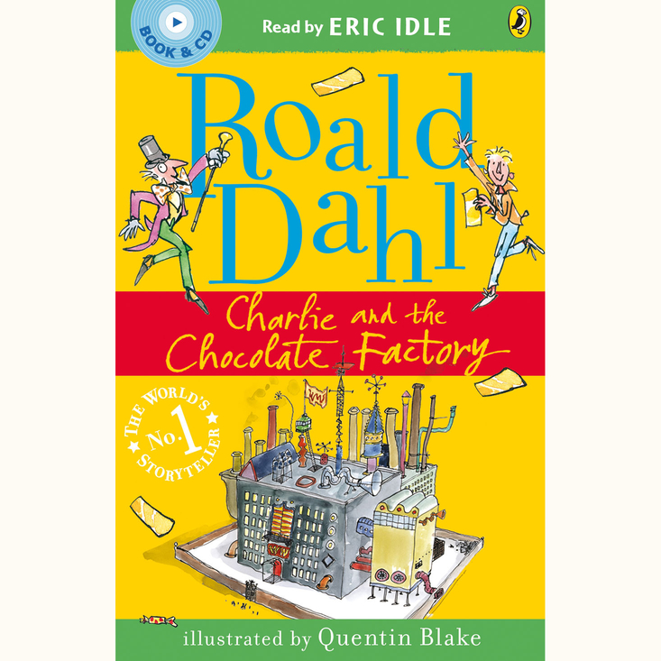

He illitrated the witches going solo and clown

