Dublin Gaelic Football-Cloze Procedure
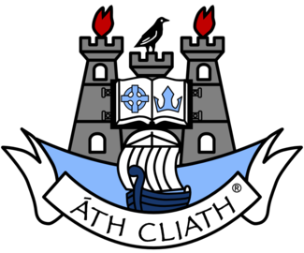
beaten | occasions | fans | recently | Croke | consecutive
history | points | responsible | Meath | county | titles

The Dublin County Board of the Gaelic Athletic Association (GAA) or Dublin GAA is one of the 32 ________ boards of the GAA in Ireland, and is __________ for Gaelic games in the Dublin Region and the Dublin inter-county teams. The team and its fans are known as "The Dubs" or "Boys in Blue". The ______ have a special affiliation with the Hill 16 end of _______ Park.

Dublin have won the Senior All-Ireland Football final on 29 _________ – only Kerry, with 37 All-Ireland _________, have won more. They defeated Kerry by six ________ in the 131st All-Ireland Final on 14 September 2019. This was their seventh championship since 2011. Dublin are the only county team in men's football or hurling to have won five ____________ All-Ireland Championships.

Meanwhile, they have won the Leinster Championship on 58 occasions, and are the current Leinster champions, having ________ Laois in 2018. This result was their consecutive eighth, making ________ and saw them become Leinster champions for the twelfth time in thirteen years. Only ______ have split their wins, winning the Leinster Championship in 2010.

Dublin have won the National Football League on 13 occasions, most __________ in 2013, 2014, 2015, 2016 and 2018. Only Kerry (20) have more league titles.

