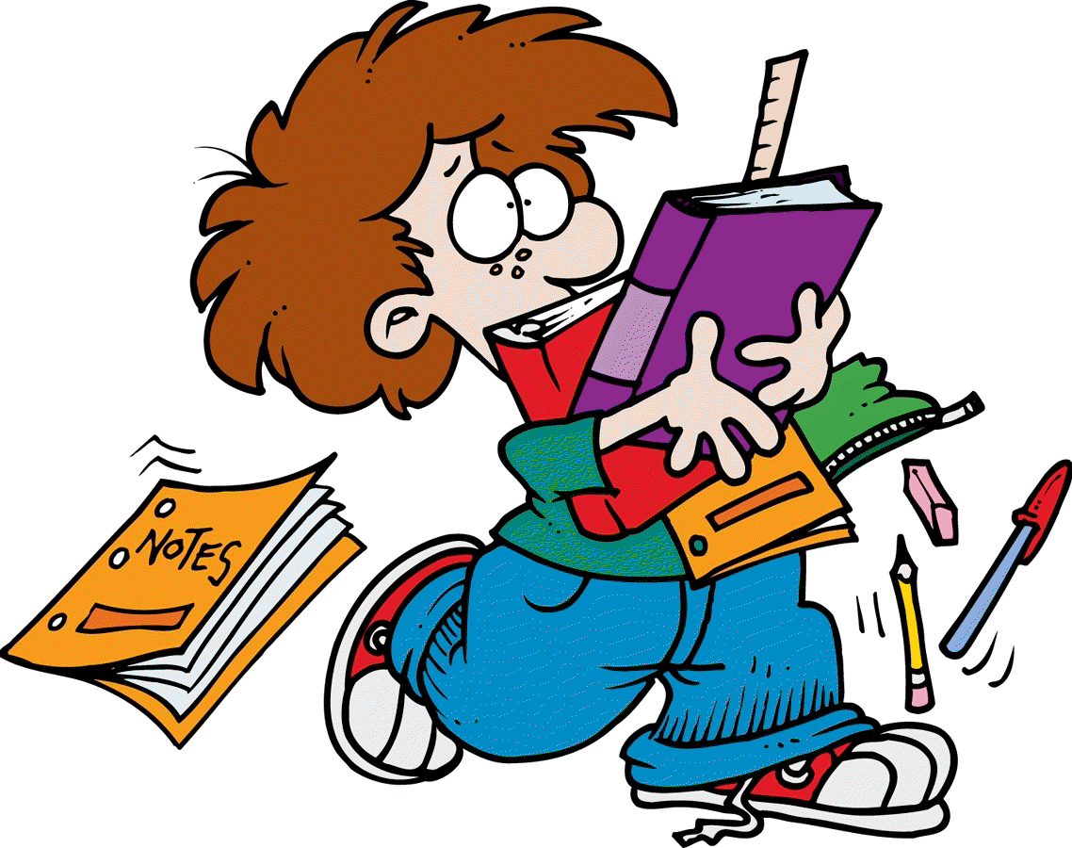Dear Parent/Guardian,

6th class students will require the following items for the 2015-2016 school year:

5 × 120 page copies
2 × 88 page copies
2 × A4 hardback copy

We will continue to use religion copies, free writing copies, handwriting copies and A5 hardback Science copies from 5th class.
Students will also need a USB Key
for their computer work.
(the 5th class one may still be used)

2 × C3 88 page sum copies

4 × A4 or B4 zipped bags for English, Gaeilge, Maths and Homework
(Labels will be provided for these in September – look out for packs of zipped bags in Easons etc.) Students know which type to get as some are already using them.

A4 Ring binder Folder Use last year’s ring binder folder if it isn’t broken
1 pack of extra strong punched pockets Remember to keep relevant sheets from 5th.

Please label copies neatly using full name and ‘6th class’. We’ll add relevant subject details in September.

A tin whistle and school tin whistle book will still be required for 6th class.

Stationery Required:
Pencils, eraser, sharpener, ruler, red pen, blue pen, protractor, compass and colouring pencils/crayons/Twistables (no markers please) plus a glue stick (e.g. pritt stick). Regular pens and pencils only please.

Most students will be able to use their book box again for 6th class.

[This list will be available on our class web page also.]

Ms. Morley

