**The Aztecs**

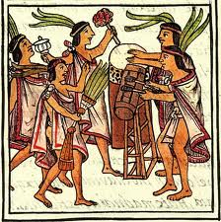

The Aztecs lived in Mexico. When they first arrived in Mexico, they were poor, ragged people who survived by eating rats, snakes, and stolen food. They were hated and rejected by all of the people who lived in the town, as they were scruffy, rude and violent. The Aztecs fought a battle with the people who lived there, and won, and so took the land for themselves.

What were the Aztecs like when they arrived in Mexico?

What did the people who already lived there think about the Aztecs?

How did the Aztecs manage to stay living in Mexico when the people hated them so much?

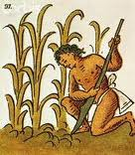

Most of the people who lived in the empire were farmers who grew lots of crops, including maize, beans, peppers, avocados, squash, cocoa, bananas, sweet potatoes, and onions. Farmers were very poor and did not own their own land. They sometimes kept slaves - people who had been captured in battle or who could not pay their debts. They worked on the farm, but didn’t get paid. If they did not obey, they were sacrificed (killed) as a gift to the gods.

Name three items that the farmers grew.

How did people become slaves?

What would happen if the slaves didn’t do as they were told?

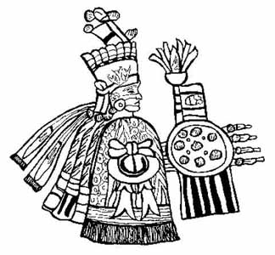

The Aztecs believed that keeping the gods happy meant that their lives would be blessed. The gods had very complicated names - the greatest numbers of sacrifices were made to the war god Huitzilopochtli and the rain god Tlaloc. Humans were sacrificed because it was believed that the human hearts and blood would “feed” the gods and keep them strong. Aztec priests sacrificed as many as 10,000 victims a year in religious sacrifices!

Can you name two Aztec gods?

Why did the Aztecs sacrifice people?

What did the Aztecs think was food for the gods?

The Aztec people were clever, and invented many things that we still have today. They invented chocolate, by discovering how to expertly blend cocoa beans! They also invented many medicines that people in Central America still use today. They were mainly made from plants and herbs. They would test their new medicines on humans that were going to be sacrificed.



Name two Aztec inventions.

How did they know that their medicines were safe?