A third vision of revision, with precision, and division!

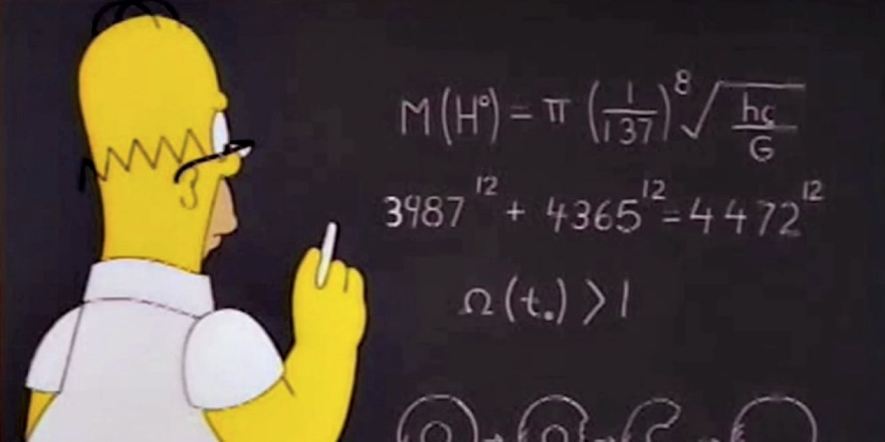
This belongs to ………………………………………………………..

Look inside for such treasures like…
- Place Value
- Decimals
- Multiplying/Dividing by 10, 100 & 1000
- Rounding numbers
- Squared and square root
…and much, much more!
What are you waiting for? Dive in!
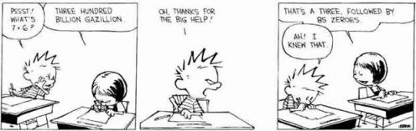
Mental calculations
Write in the missing numbers.
- 463450 + 12320 = _______________________
- 847850 – 34450 = ________________________
- 66.6 x 1000 = ___________________________
- 47 ÷ 100 = _____________________________
- 357.39 x 100 = _________________________
- 52.85 x 1000 = __________________________
- 458.2 ÷ 10 = ____________________________
- 79.97 x 100 = ___________________________
- 50.07 ÷ 1000 = __________________________
- 14 x 6 = ____________________________
- 16 x 5 = ___________________________
- 13.6 + 12.6 = _______________________
- 63 + 156 = _________________________
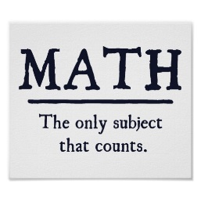
Solve these questions. Show your method clearly.
- 635,422 + 40,100

- 8.08 + 715

- 7.91 + ……….. = 10

- 2.15 + …….. = 5

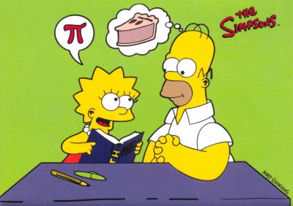
Lay out and solve these questions
- 7582 – 4695

- 30,000 – 18,590

- 5326 + 2839

- 2767 + 6728

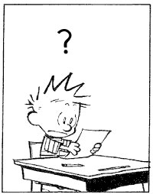
Word problems…read it carefully! RNCA!
- Mr Howorth’s band, The Brotherhood of Rock, played at a stadium with 13703 seats. He played 100 concerts and each time, it was full. How many people did he play to altogether?

- Mrs Harber thinks of a secret number. She divides it by 10. The answer is 82. What is her secret number?

- A sky-diver jumps from 8000 feet. After 1560 feet, he opens his parachute. How far is it to the ground when his parachute opens?

- A hyena chases after a gazelle for 5.2 km before walking for 2.8 km. It then runs again and catches it after another 2.4 km, and has a tasty meal. How far did the hyena travel altogether?

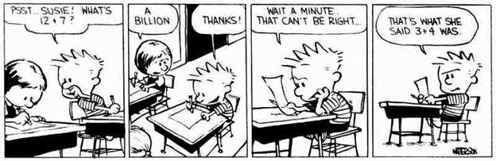
Decimal action!
Round the decimal numbers to the nearest whole number.
- 45.51
- 9.49
Round the decimal numbers to the nearest tenth
- 10.36
- 38.74
Write the decimal numbers in order, largest first.
- 4.86 4.806 4.089 4.8599
________ _______ ________ ________
- What is the decimal equivalent of these fractions?
- $\frac{5}{10}$ = b) $\frac{7}{20}$ =
c) $\frac{45}{50}$ = d) $\frac{14}{25}$ =
e) $\frac{2}{5}$= f) $\frac{3}{4}$ =
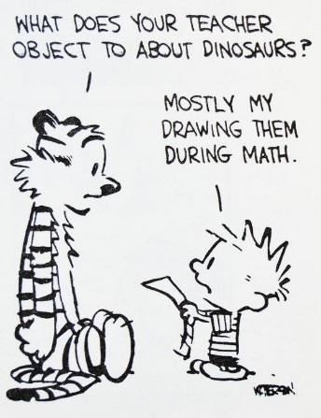
Multiples and friends!
- Write in what the missing numbers could be.
- Two common multiples of 4 and 6 that are less than 30
_______________ and __________________

- Three common multiples of 3 and 7 that are less than 100
____________ and __________and____________

- What is $\sqrt{81}$? ______________
- What is 6² ? ______________________
- 5² + 5² ? ________________________
- Is 7 a factor of 56? ___________________
- Is 3 a factor of 241? ___________________
- Is 381 a multiple of 4? _________________
- What is $\sqrt{100}$ ? ______________________
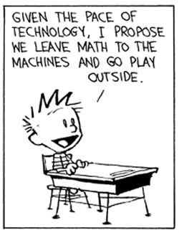
Bits and bobs to finish the job!
- Round 64663 to:
The nearest 1000 _____________________
The nearest 10 _____________________
The nearest 100 _____________________
- Look at the following numbers: if they are divisible by 3, circle them. If they are divisible by 4, draw a square around them.

213 616 825 248 214

- Mrs Harber thinks of a number. Once it has been multiplied by 100, the answer is 5555. What is the original number?

- Mr Howorth thinks of a number. Once it has been multiplied by 1000, the answer is 4200.1
What is the original number?

_________________________________________

